Supplementary material

**1 -Details on collaring process**

In addition to GPS units, collars also included a small audio recorder (Edic-mini Tiny+ A77; TS-Market, Russia). Axy-Trek units (used in 2021) also collected accelerometry data, however only GPS data was used in the present study. The closing mechanism consisted of 2 magnets (1*5*5mm) glued to 3-D printed plastic clasps at each end of the leather strap, designed to be able to close easily but to require human intervention to open.

We deployed most collars in the morning hours, when meerkats were at their communal sleeping burrow to warm up in the sun or groom each other prior to foraging. Some were also deployed in the afternoon hours when meerkats stopped foraging and rested in the heat, or while meerkats were grooming one another at the sleeping burrow before descending into the burrow for the night. A few collars were also opportunistically deployed in conjunction with scheduled captures of individuals for other purposes at the long-term study.

A collar of the appropriate size was selected based on prior neck measurements of the target individual. We put it on after carefully approaching and grooming the target meerkat and only if the animal remained stationary and showed no sign of discomfort or attempted escape. Some individuals were collared while drinking water which was presented for distraction (figure S1). No more than two attempts of collaring were done per day per individual to prevent dishabituation. After successful collaring, individuals were observed for at least ten minutes and the collar was removed if they exhibited any kind of unusual behavior for more than a few minutes (e.g. scratching at the collar, trying to remove it). This happened in very few cases, always on the smallest individuals. In these few cases we removed the collars and, in some instances, re-deployed different collars on a subsequent day (if collar fit was determined to be the issue). At the end of data collection, collars were taken off much in the same way as they were put on or by cutting the leather straps using mini diagonal cutters, though sometimes as well during foraging since removal could be done much more quickly and easily than deployment. See table S1 and S2 below for information on group composition, deployment timing and individual characteristics.

Across all groups, a total of 14 non-juvenile individuals that could not be collared (this included one dominant per group already carrying a VHF collar for tracking) or for which collar GPS had failed mid-session were instead continuously recorded by a human observer. A GPS tag equivalent to those deployed in collars was strapped to a directional microphone on the end of a telescopic pole and kept within 1 meter of the foraging meerkat for the 3-hour duration of each session. At the same time, the observer vocally described the focal meerkat’s behavior using a handheld microphone, including noting occasional moments when the meerkat went out of range of the pole (these portions were then removed from the recorded trajectories). The numbers of meerkats which could be focal-followed in this way depended on the number of observers available (never more than 3), therefore not every non-juvenile could be recorded on every day, especially as GPS tags started failing due to low battery towards the end of each deployment round. We processed the data of focal followed individuals in the same way as data from meerkats wearing collars (see main text).

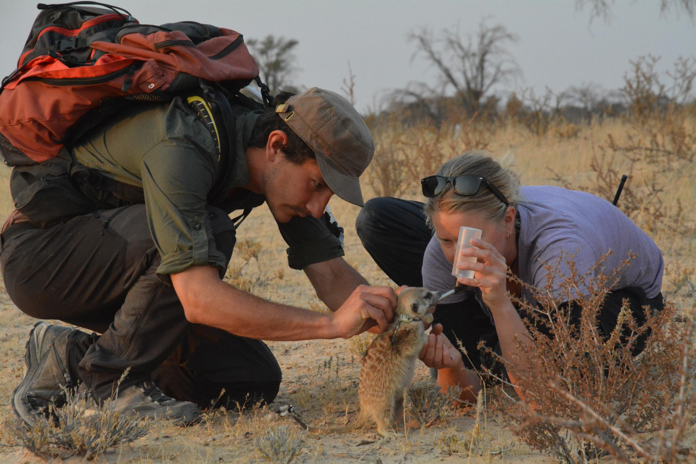Figure S1. Picture showing the collar deployment process.

Table S1. Summary of group composition and data collection. df = dominant female ; dm = dominant male ; ye = yearlings ; sub = sub-adult ; juv = juvenile. ‘*Total time used*’ indicates the amount of time steps that were used in the analyses, once irrelevant data were removed (see main text for details).

|  |  |  |  |  |  |
| --- | --- | --- | --- | --- | --- |
| Group name | Group size | Group composition  (recorded / present) | Recording  Period | # recording days  used | Total time used (hours) |
| HM17 | 7 | 1/1 df ; 1/1 dm ;  3/3 ye ; 2/2 sub | 06 Aug –  08 Sep 2017 | 13  (3 deployments) | 37.2 |
| HM19 | 18 | 1/1 df ; 1/1 dm ;  3/3 ad ; 4/4 ye ;  3/4 sub ; 0/5 juv | 23 Jun –  19 July 2019 | 12  (2 deployments) | 31.4 |
| L19 | 19 | 1/1 df ; 1/1 dm ;  2/2 ad ; 4/4 ye ;  5/5 sub ; 0/6 juv | 05 Aug –  12 Aug 2019 | 8  (1 deployment) | 18.5 |
| ZU21 | 13 | 1/1 df ; 1/1 dm ;  0/1 ad ; 6/7 ye ;  0/3 juv | 16 May –  24 May 2021 | 8  (1 deployment) | 15.3 |
| NQ21 | 11 | 1/1 df ; 1/1 dm ;  6/6 ye ; 0/3 juv | 11 Aug –  17 Aug 2021 | 5  (1 deployment) | 8.8 |

Table S2. Information on all individuals composing the five recorded groups, with each line representing one individual. Three individual appear twice as they were present both in HM19 and HM19. (P) next to an individual’s name indicate that this individual was pregnant for at least part of the data collection. DOB = Date Of Birth. ‘*Tenure*’ indicates the dates at which dominance was established (only for dominant individuals). ‘*Natal’* indicates whether or not the individual was born in the group it was recorded in. ‘*Recording type’* indicates how movement data was collected: *collar* = using gps tags mounted on a collar ; *focal* = following the individual with a gps unit strapped to a pole ; *none* = this individual could not be recorded. *‘# record days’* indicates the number of days this individual was recorded out of all the days used in the analysis. *‘# absent days*’ indicates the number of days this individual was absent from the group, out of all the days used in the analysis, with the reason in parentheses: *BS* = baby-sitting at the communal burrow ; *EV* = evicted from the group ; *ROV* = roving. A given individual was thus recorded on every used day if the numbers in the last two columns add up to the number of recording days used for its group as shown in table S1.

|  |  |  |  |  |  |  |  |  |  |  |
| --- | --- | --- | --- | --- | --- | --- | --- | --- | --- | --- |
| **Group** | **Name** | **Code** | **DOB** | **Sex** | **Status** | **Tenure** | **Natal** | **Recording type** | **# record days** | **# absent days** |
| HM17 | AJB (P) | HM17_1 | 21.08.2013 | F | DominantF | 10.11.2016 | N | Focal | 13 | 0 |
| HM17 | PET | HM17_2 | 21.12.2011 | M | DominantM | 10.11.2016 | N | Collar | 13 | 0 |
| HM17 | FLINT | HM17_3 | 27.10.2016 | F | Yearling | NA | Y | Collar | 7 | 3 (BS) |
| HM17 | RIPTIDE | HM17_4 | 27.10.2016 | M | Yearling | NA | Y | Collar | 13 | 0 |
| HM17 | REEPICHEEP | HM17_5 | 27.10.2016 | M | Yearling | NA | Y | Collar + focal | 1 + 7 | 1 (BS) |
| HM17 | COSMO | HM17_6 | 28.12.2016 | M | Sub-Adult | NA | Y | Collar | 11 | 1 (BS) |
| HM17 | DANTE | HM17_7 | 28.12.2016 | M | Sub-Adult | NA | Y | Collar | 13 | 1 (BS) |
| HM19 | FLINT (P) | HM19_1 | 27.10.2016 | F | DominantF | 10.04.2019 | Y | Collar + focal | 7 + 5 | 0 |
| HM19 | PET | HM19_2 | 21.12.2011 | M | DominantM | 10.11.2016 | N | Focal | 12 | 0 |
| HM19 | DANTE | HM19_3 | 28.12.2016 | M | Adult | NA | Y | Collar | 12 | 0 |
| HM19 | GUACAMOLE | HM19_4 | 01.09.2017 | M | Adult | NA | Y | Collar + focal | 4 + 2 | 0 |
| HM19 | DOUBLE FLUFF | HM19_5 | 01.09.2017 | F | Adult | NA | Y | Focal | 6 | 6 (EV+BS) |
| HM19 | TWIRL | HM19_6 | 15.05.2018 | M | Yearling | NA | Y | Collar | 9 | 3 (BS) |
| HM19 | MOZARELLA | HM19_7 | 15.05.2018 | F | Yearling | NA | Y | Collar | 12 | 0 |
| HM19 | OSCAR JUNIOR | HM19_8 | 15.05.2018 | M | Yearling | NA | Y | Collar | 10 | 2 (BS) |
| HM19 | PINGU | HM19_9 | 15.05.2018 | M | Yearling | NA | Y | Collar | 8 | 0 |
| HM19 | MUNCHKIN | HM19_10 | 26.09.2018 | F | Sub-Adult | NA | Y | None | 0 | 2 (BS) |
| HM19 | SHAMROCK | HM19_11 | 26.09.2018 | M | Sub-Adult | NA | Y | Collar | 12 | 0 |
| HM19 | ACE | HM19_12 | 26.09.2018 | F | Sub-Adult | NA | Y | Collar + focal | 8 + 1 | 0 |
| HM19 | SHANDY | HM19_13 | 26.09.2018 | M | Sub-Adult | NA | Y | Collar | 7 | 0 |
| HM19 | DARJEELING | HM19_14 | 08.02.2019 | F | Juvenile | NA | Y | None | 0 | 0 |
| HM19 | SENCHA | HM19_15 | 08.02.2019 | F | Juvenile | NA | Y | None | 0 | 0 |
| HM19 | KAJESS | HM19_16 | 08.02.2019 | F | Juvenile | NA | Y | None | 0 | 0 |
| HM19 | BELPHEGOR | HM19_17 | 08.02.2019 | M | Juvenile | NA | Y | None | 0 | 0 |
| HM19 | MUGI | HM19_18 | 08.02.2019 | M | Juvenile | NA | Y | None | 0 | 0 |
| L19 | SIGMA (P) | L19_1 | 06.11.2016 | F | DominantF | 26.05.2019 | Y | Collar | 8 | 0 |
| L19 | POLON | L19_2 | 25.04.2016 | M | DominantM | 26.01.2017 | N | Focal | 8 | 0 |
| L19 | FINNICK | L19_3 | 23.04.2017 | M | Adult | NA | Y | Collar | 8 | 0 |
| L19 | TONKS | L19_4 | 23.04.2017 | F | Adult | NA | Y | Collar | 8 | 0 |
| L19 | THURSDAY | L19_5 | 23.02.2018 | M | Yearling | NA | Y | Collar | 4 | 0 |
| L19 | ANNIE | L19_6 | 23.02.2018 | F | Yearling | NA | Y | Focal | 3 | 0 |
| L19 | WEASEL | L19_7 | 23.02.2018 | F | Yearling | NA | Y | Collar | 8 | 0 |
| L19 | FLEDERMAUS | L19_8 | 23.02.2018 | M | Yearling | NA | Y | Focal | 3 | 1 (ROV) |
| L19 | HAOPIA | L19_9 | 18.07.2018 | F | Sub-Adult | NA | Y | Collar | 8 | 0 |
| L19 | LUTHER | L19_10 | 18.07.2018 | M | Sub-Adult | NA | Y | Collar | 6 | 0 |
| L19 | LENNON | L19_11 | 18.07.2018 | F | Sub-Adult | NA | Y | Collar | 8 | 0 |
| L19 | ISRAEL | L19_12 | 18.07.2018 | M | Sub-Adult | NA | Y | Focal | 2 | 0 |
| L19 | NELSON | L19_13 | 18.07.2018 | M | Sub-Adult | NA | Y | Collar | 8 | 0 |
| L19 | SQUELCH | L19_14 | 13.03.2019 | F | Juvenile | NA | Y | None | 0 | 0 |
| L19 | SQUEAL | L19_15 | 13.03.2019 | M | Juvenile | NA | Y | None | 0 | 0 |
| L19 | SIZZLE | L19_16 | 13.03.2019 | M | Juvenile | NA | Y | None | 0 | 0 |
| L19 | SLOP | L19_17 | 13.03.2019 | M | Juvenile | NA | Y | None | 0 | 0 |
| L19 | SPLAT | L19_18 | 13.03.2019 | M | Juvenile | NA | Y | None | 0 | 0 |
| L19 | SAUSAGE | L19_19 | 13.03.2019 | F | Juvenile | NA | Y | None | 0 | 0 |
| ZU21 | SPRUDDEL | ZU21_1 | 10.03.2017 | F | DominantF | 19.05.2019 | Y | Focal | 8 | 0 |
| ZU21 | SCUZI | ZU21_2 | 02.05.2018 | M | DominantM | 01.01.2020 | N | Focal | 6 | 0 |
| ZU21 | JAY-A-ROD | ZU21_3 | 02.05.2018 | M | Adult | NA | N | None | 0 | 0 |
| ZU21 | SALAZAR | ZU21_4 | 09.03.2020 | F | Yearling | NA | Y | Collar | 8 | 0 |
| ZU21 | HELGA | ZU21_5 | 09.03.2020 | F | Yearling | NA | Y | Collar | 8 | 0 |
| ZU21 | GODRIC | ZU21_6 | 09.03.2020 | M | Yearling | NA | Y | Collar | 7 | 0 |
| ZU21 | ROWENA | ZU21_7 | 09.03.2020 | F | Yearling | NA | Y | Collar | 8 | 0 |
| ZU21 | BEAR | ZU21_8 | 27.03.2020 | M | Yearling | NA | Y | Collar | 2 | 0 |
| ZU21 | MION | ZU21_9 | 27.03.2020 | M | Yearling | NA | Y | Collar | 7 | 0 |
| ZU21 | ZUMA | ZU21_10 | 27.03.2020 | M | Yearling | NA | Y | Collar | 6 | 0 |
| ZU21 | SPOEKIES | ZU21_11 | 05.01.2021 | F | Juvenile | NA | Y | None | 0 | 0 |
| ZU21 | WILLOW | ZU21_12 | 05.01.2021 | M | Juvenile | NA | Y | None | 0 | 0 |
| ZU21 | TAZARA | ZU21_13 | 05.01.2021 | M | Juvenile | NA | Y | None | 0 | 0 |
| NQ21 | MANZA | NQ21_1 | 11.11.2019 | F | DominantF | 08.07.2021 | Y | Collar | 5 | 0 |
| NQ21 | UMFANA | NQ21_2 | 07.04.2018 | M | DominantM | 01.07.2021 | N | Focal | 5 | 0 |
| NQ21 | ZUKO | NQ21_3 | 11.11.2019 | M | Yearling | NA | Y | Collar | 4 | 0 |
| NQ21 | MONONOKE | NQ21_4 | 11.11.2019 | F | Yearling | NA | Y | Collar | 5 | 0 |
| NQ21 | HICCUP | NQ21_5 | 01.02.2020 | F | Yearling | NA | Y | Focal | 2 | 0 |
| NQ21 | BARNEY | NQ21_6 | 22.04.2020 | M | Yearling | NA | Y | Collar | 5 | 0 |
| NQ21 | COOPER | NQ21_7 | 22.04.2020 | M | Yearling | NA | Y | Focal | 1 | 0 |
| NQ21 | MEGARA | NQ21_8 | 22.04.2020 | F | Yearling | NA | Y | Collar | 5 | 0 |
| NQ21 | MIA | NQ21_9 | 07.03.2021 | F | Juvenile | NA | Y | None | 0 | 0 |
| NQ21 | FREDI | NQ21_10 | 07.03.2021 | M | Juvenile | NA | Y | None | 0 | 0 |
| NQ21 | HANSPETER | NQ21_11 | 07.03.2021 | M | Juvenile | NA | Y | None | 0 | 0 |

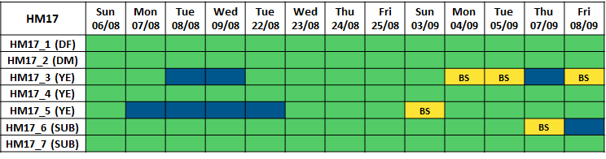Tables S3. Summary of data collection effort for all individual (rows) on each recording day (columns). A green cell indicates that the individual was present in the group and recorded on that particular date, a dark blue cell indicates that it was present in the group but not recorded, a yellow cell indicates that it was absent from the group, with reason indicated as in table S2.

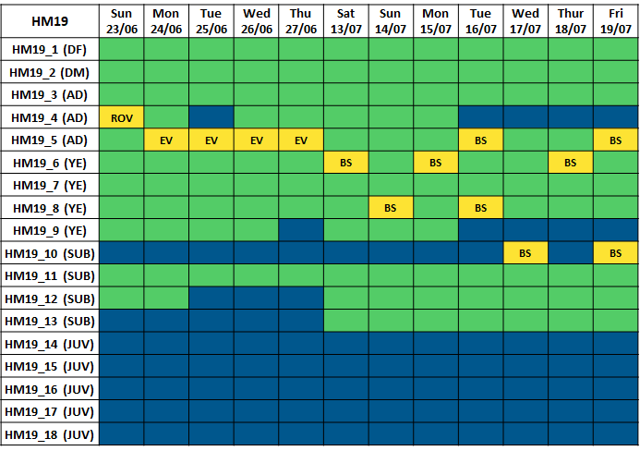

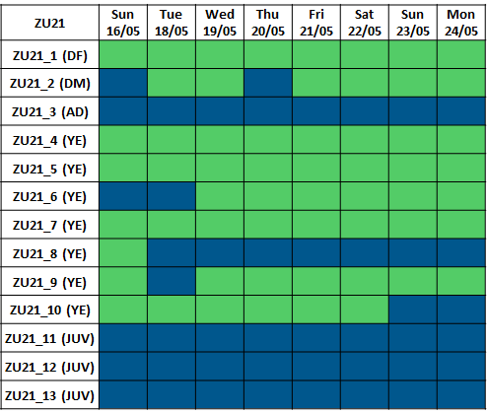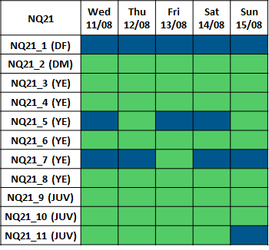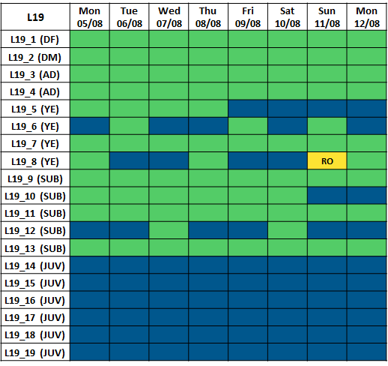

**2 - Alternative influence scores based on individual positions**

Depending on the movement characteristics of the social species under study, individual cues that exert influence on the rest of the group’s movement can vary. In addition to the two influence metrics based on individual relative movement (i.e. the group follows their speed and/or direction of motion, see main text), we also considered the possibility that individuals might exert influence via their relative spatial positioning (i.e. the group moves toward their position in space).

**Position turning influence** is defined as the probability that the group turns in a given direction (right or left) as a function of an individual’s position to the left or right of the group center. Similarly, **position speeding influence** is defined as the probability that the group speeds up as a function of the front-back position of an individual.

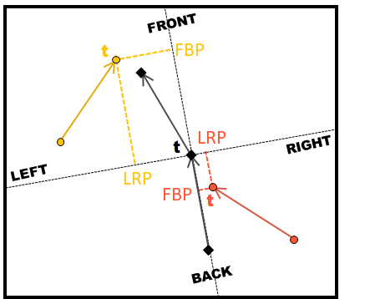Similar to movement turning influence presented in the main text, the binary response variable for position turning influence is the probability of the group to turn right, but the continuous predictor variable is the left-right position, defined as the y-value of the individual’s past position in the group reference frame (see figure S1 below). Similarly, the binary response variable for position speeding influence is the probability of the group to speed up and the continuous predictor variable is the front-back position, defined as the x-value of the individual’s past position in the group reference frame. See methods in the main text for more details about data processing.

Figure S2. Calculation of individual metrics used to get the position turning position speeding influence scores. Left-right position (LRP) is the y-value of the individual’s current position in the group reference frame (doted line) and front-back position (FBP) is the x-value of the individual’s current position in the group reference frame. Colored solid arrows represent the past velocity vectors of two individual, black solid arrows represent the past and future velocity vectors of the group centroid. See figure 2 in the main text for more details on discretization process and calculation of the group reference frame.

The probability of the group to turn right as a function of individual left-right position (position turning influence) and the probability of the group to speed up as a function of individual front-back position (position speeding influence) were then modelled similarly to the influence metrics presented in the main text, using a modified logistic function (see equation 1 in the main text), and influence scores were derived from it (see figures 2E and 2F in the main text).

Figure S3. Predicted position influence scores for each recorded individual (colored dots) in the 5 study groups (vertical axis). Dot color indicates individual status as shown in the legend, dot size is proportional to the quantity of data available. Dotted vertical lines represent baseline probabilities for the outcome of group decision (50% percent chance of turning left or right for turning influence and overall probability to speed up for each group for speeding influence). (A) Position turning influence score represents the probability that the group turns toward the side (left or right) where the individual was located. (B) Speeding influence score represents the probability that the group speeds up after that individual was in the front half of the group.

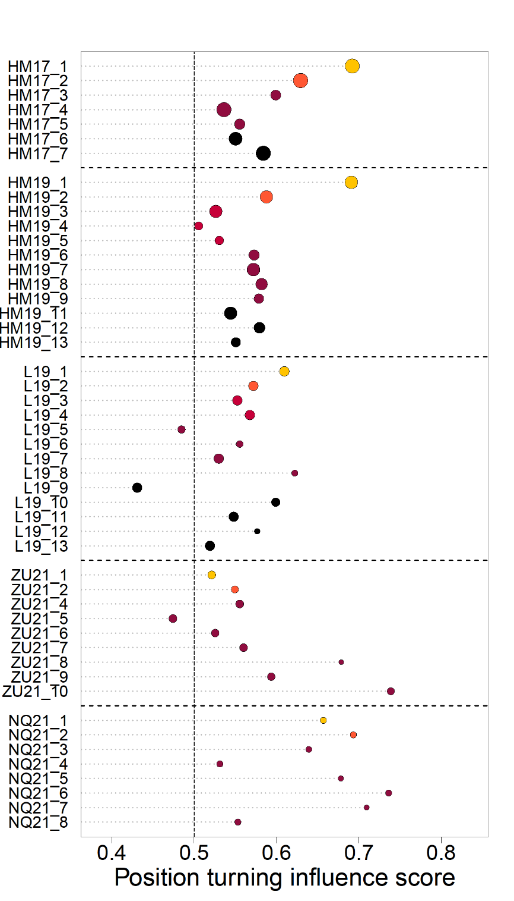

**A.**

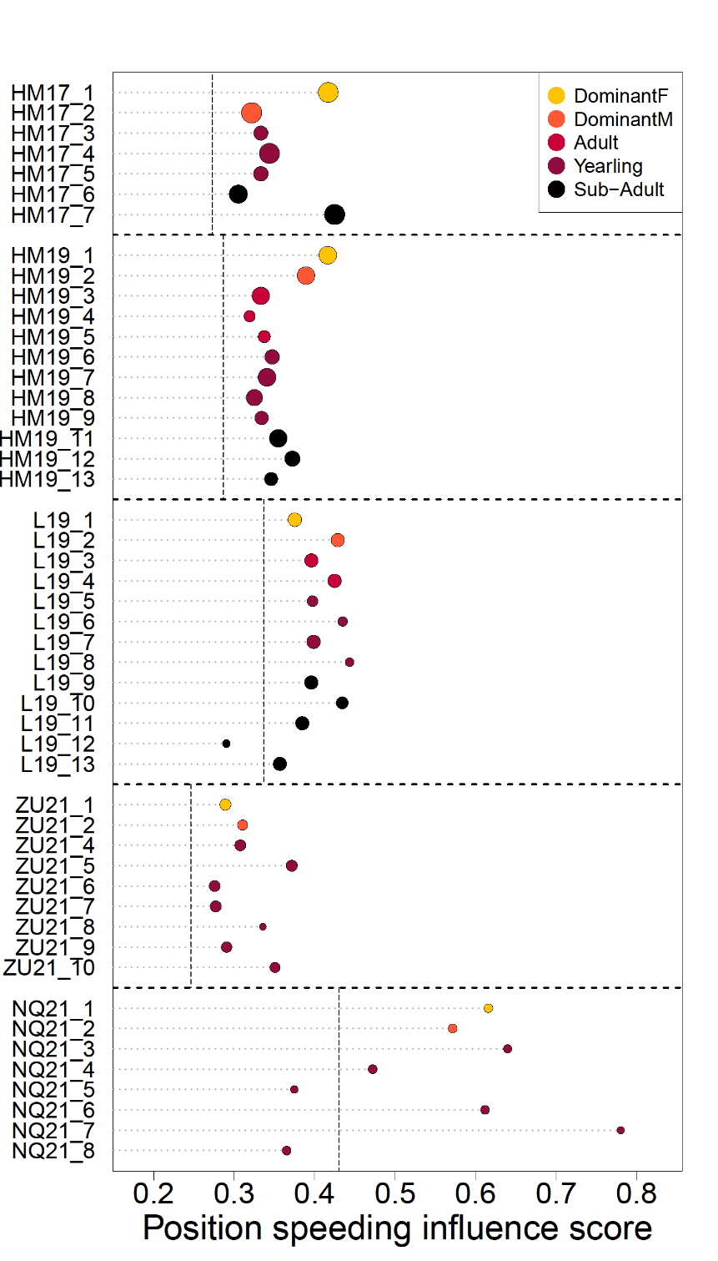

**B.**

**3 - Logistic modelling with two predictor variables**

To compare the strength of the two possible effects (position and movement), we conducted an additional analysis in which we modelled the overall probability of groups to turn right as a function of both their members’ past left-right positions and past left-right movements relative to the group’s past heading. Similarly, we modelled the probability of groups to speed up as a function of both their members’ past front-back positions and past front-back movements relative to the group’s heading (see below and supplements for detailed explanation of the process).

We first computed all four individual variables (left-right movement and position and front-back movement and position) as detailed in the main text and in section 3 above. We then fit two models, one for turning influence and one for speeding influence, using data from all individuals across our five groups. The function we used for the models is a modified version of equation 1 presented in the main text, allowing for the use of two predictor variables (equation 2 below):

$f\left(x\right)= [α \frac{1}{1+e^{-\left(β_{1}x_{1}+β_{2}x_{2} \right)}}] + \left[γ \left(1-α\right)\right]$ (2)

Here, *f(x)* represents the probability of the group either turning right or speeding up, depending on the type of influence, as in equation 1. *x1* represents individual position (left-right or front-back) and *x2* represents individual movement (left-right or front-back) as described in the main text. *α*, *β1* and *β2* were fit for all individuals combined, while *γ* was fixed to either 0.5 for turning influence (assuming an overall equal probability to turn left or right), or to the aggregate probability of all groups to speed up across all the data for speeding influence.

These analyses revealed that in general, the future direction and speed of the group was more strongly associated with individuals’ relative speed than with their relative spatial positions (figure S4). This result also held at the group and individual level. This result informed our decision to focus our main analyses on movement rather than position as a driver of influence

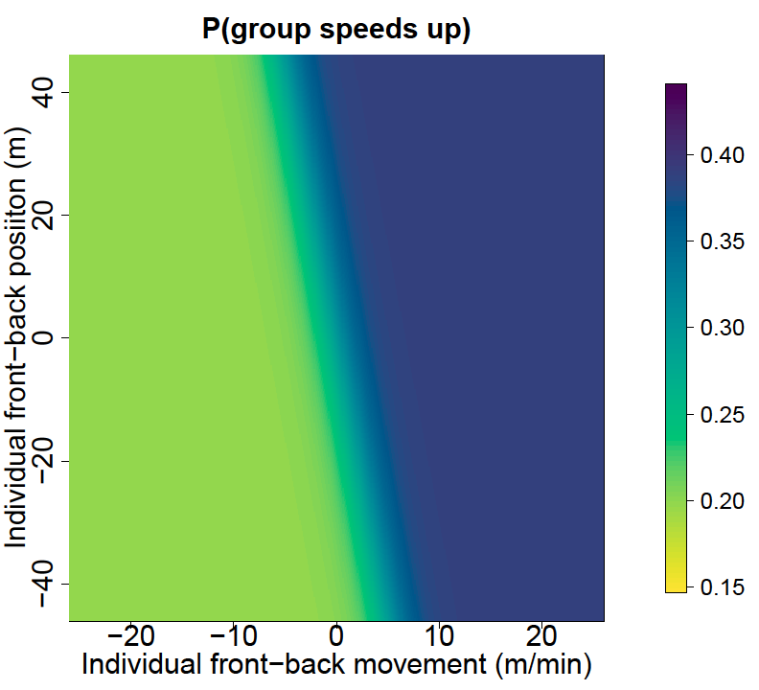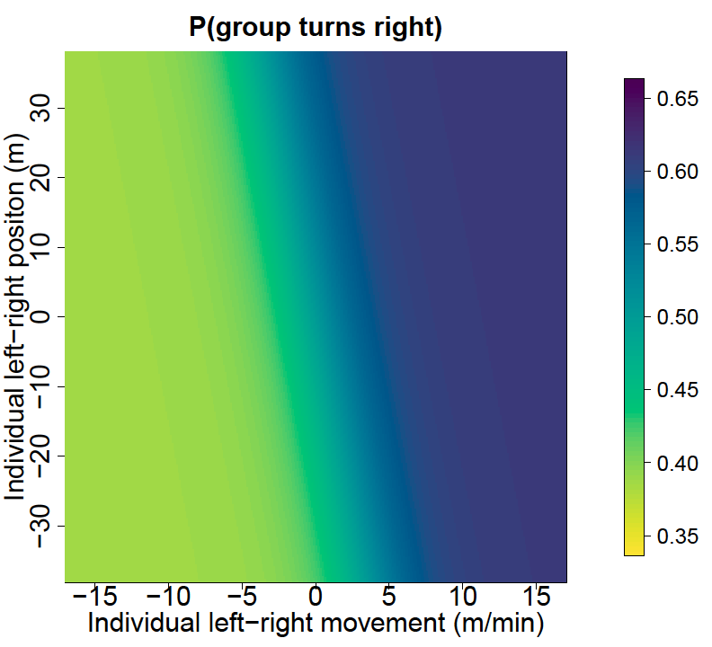

**A.**

**B.**

Figure S4. Predicted group outcome as a function of individual position and movement, modeled using data across all groups. (A) Predicted probability of a group to turn right as a function of individual left-right position (y-axis) and individual left-right speed (x-axis). (B) Predicted probability of a group to speed up as a function of individual front-back position (y-axis) and front-back movement (x-axis). Axis limits extend to the 0.01-0.99% quantiles of each variable to show them on comparable scales.

**4 – Distribution of group metrics**

The figures below show the distribution of three group-level metric for each five groups: the **group spread**, calculated by averaging all distances between group members at any given moment, the **turning angle**, calculated as the angle between the past and future direction of movement of the group, and the **step duration**, calculated as the time taken by the group centroid to move 10m. For a given metric, x-axis is kept constant for easier comparison across groups.

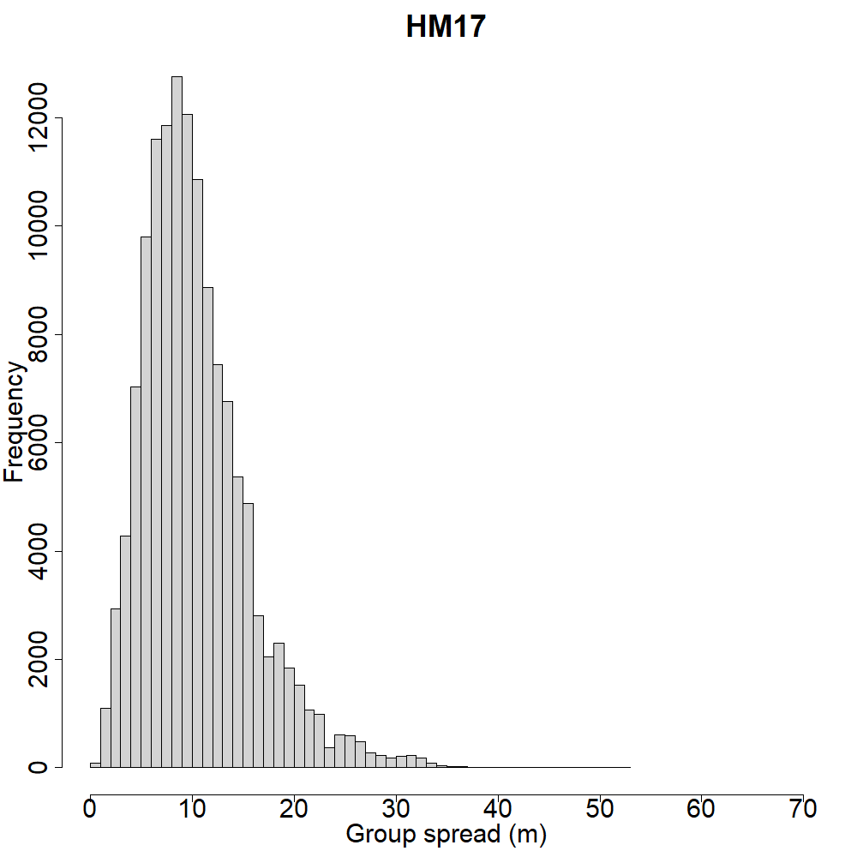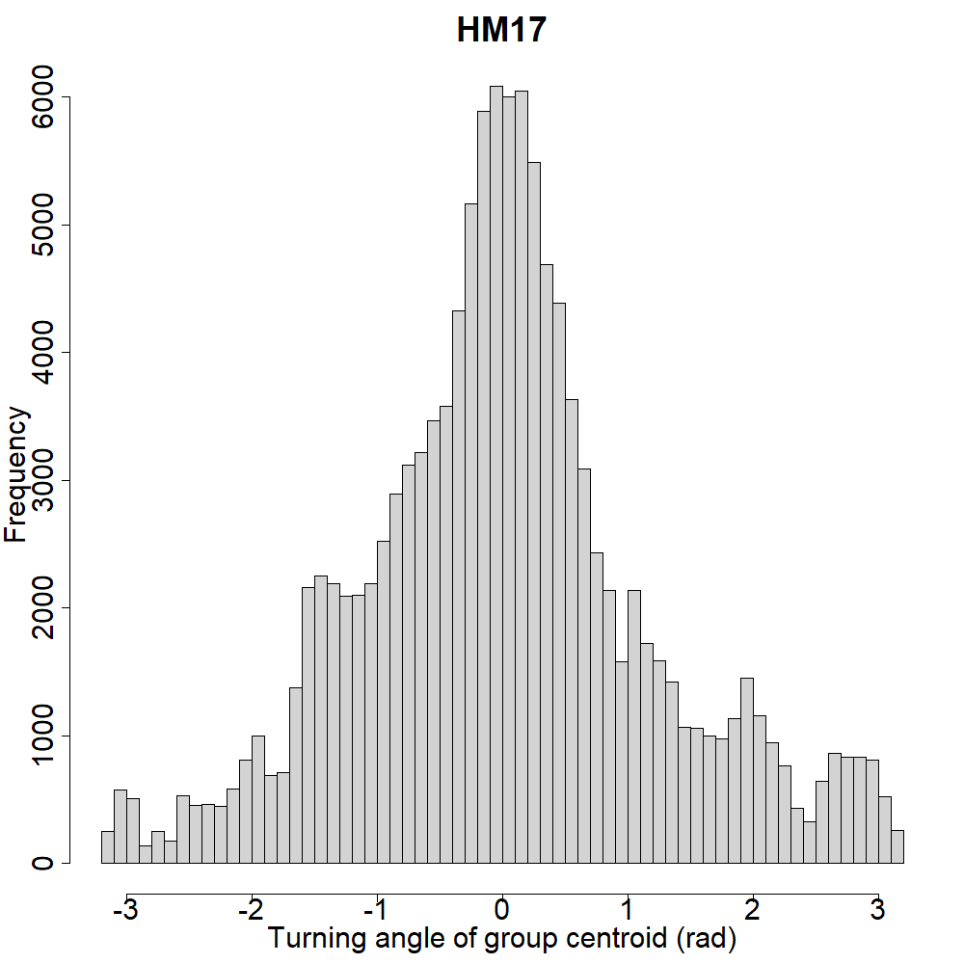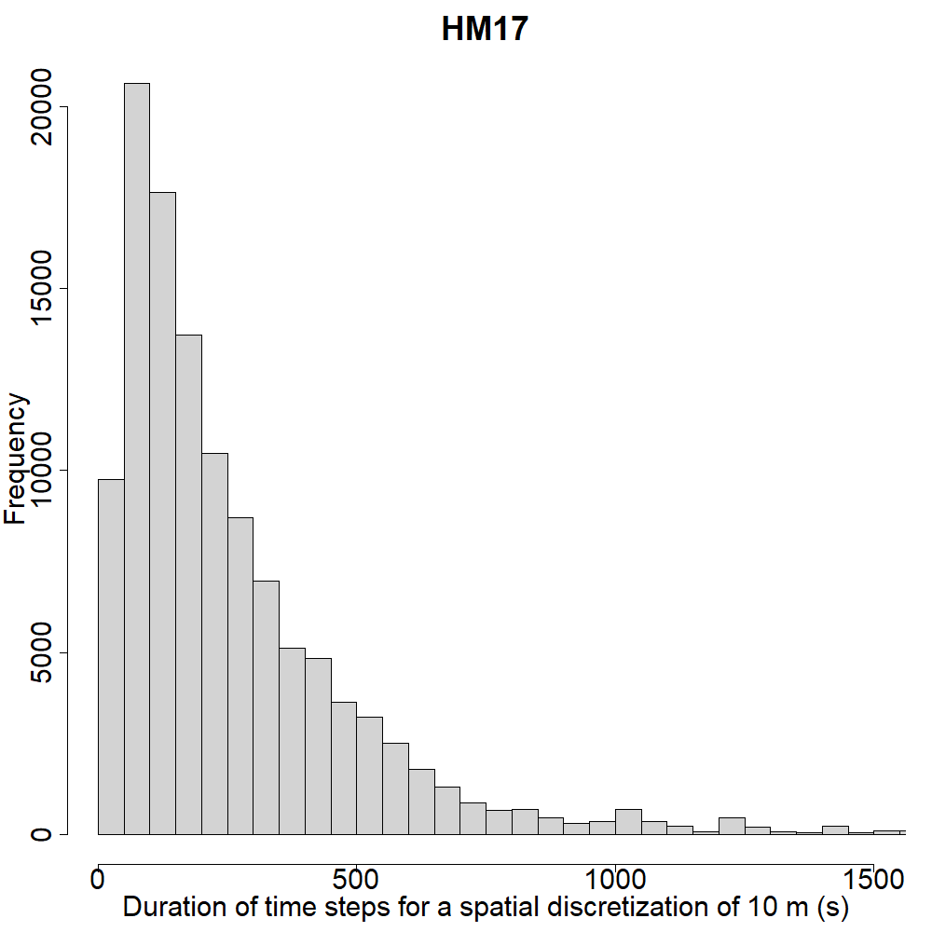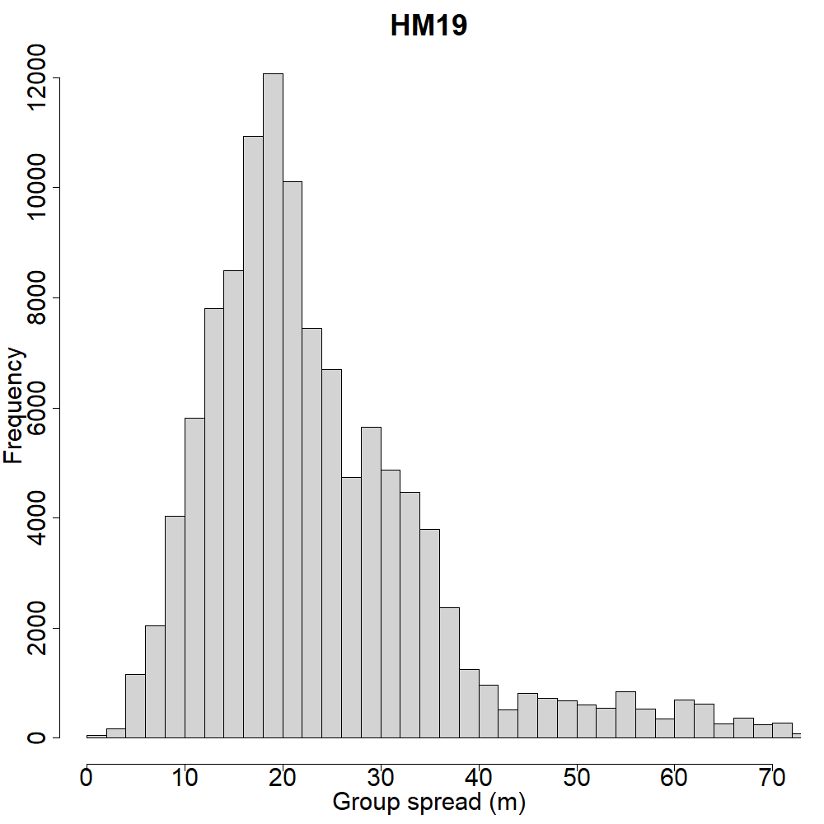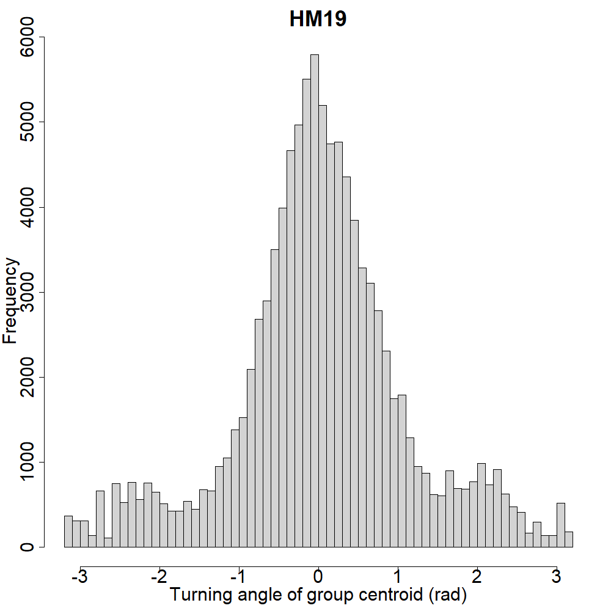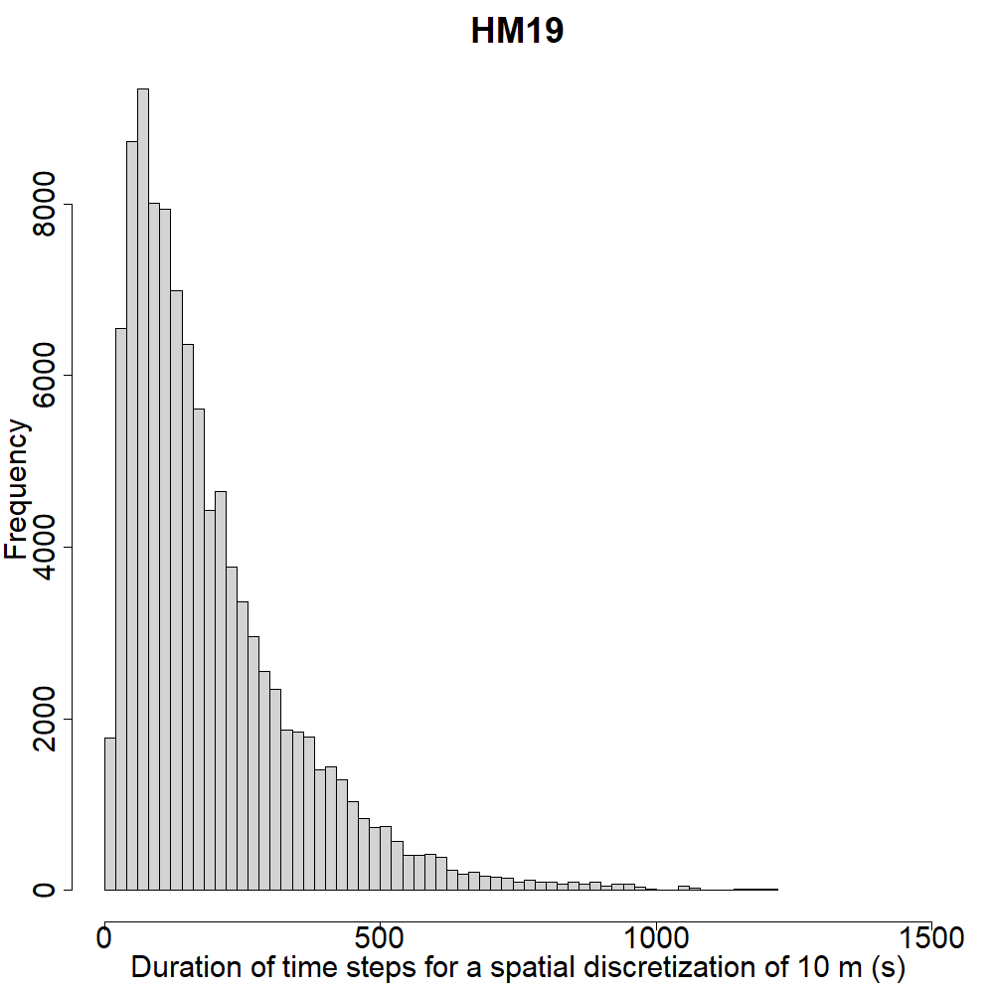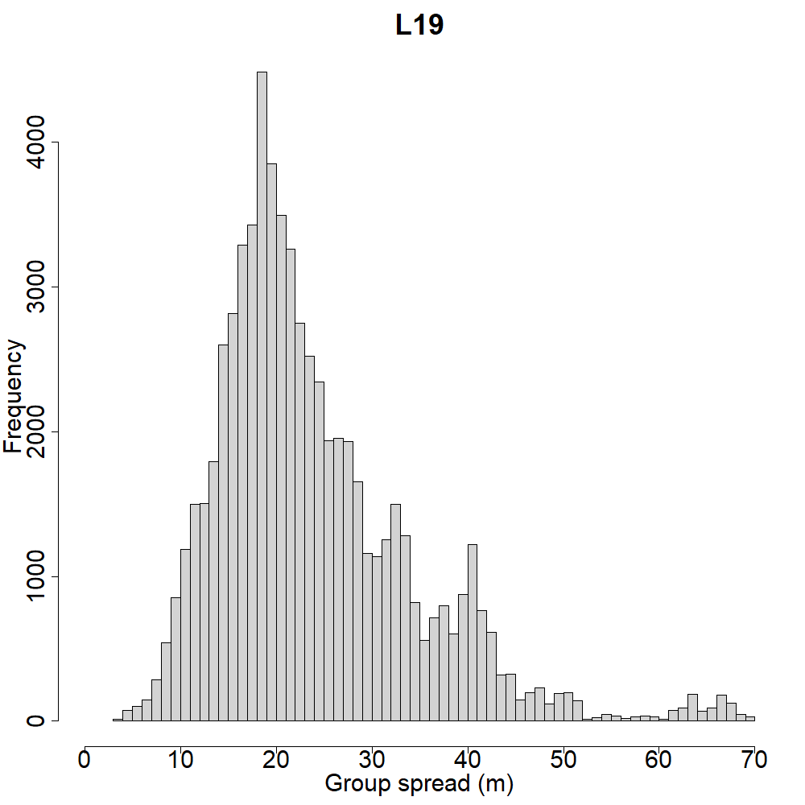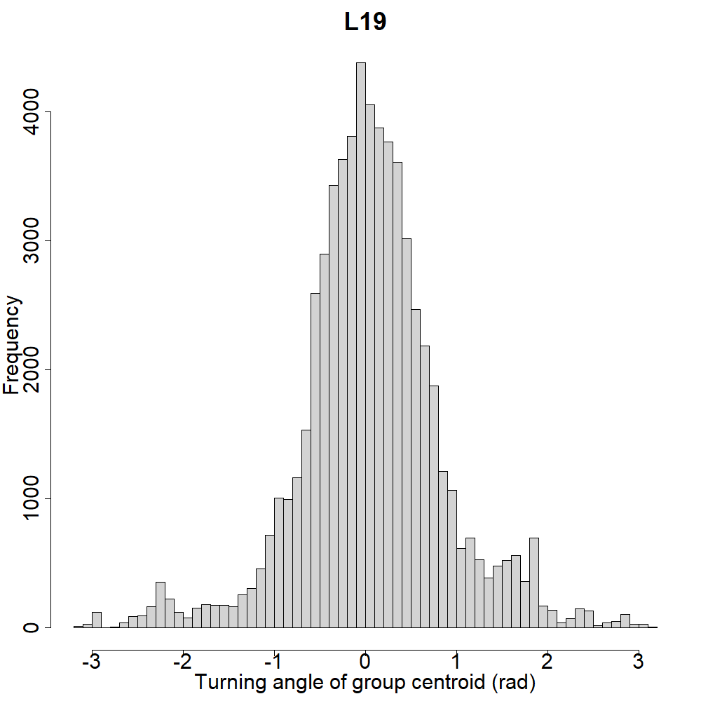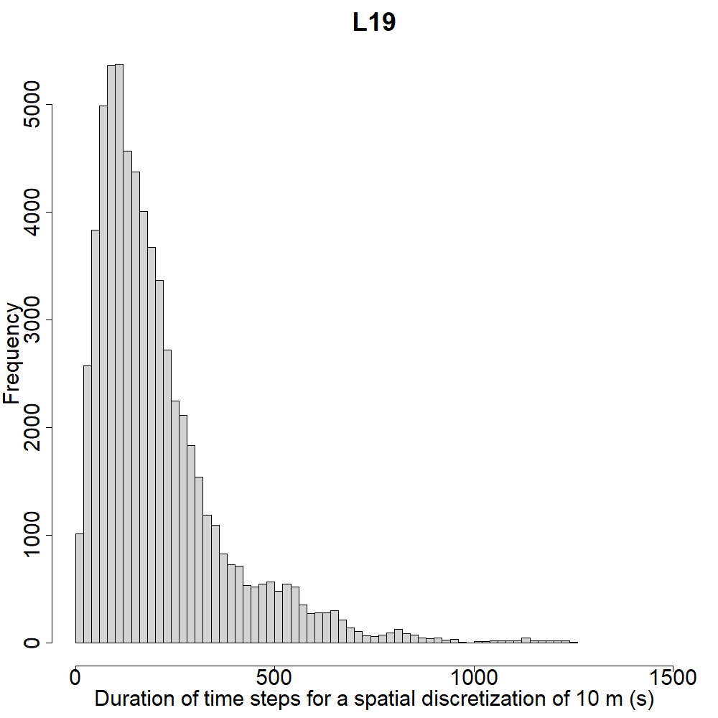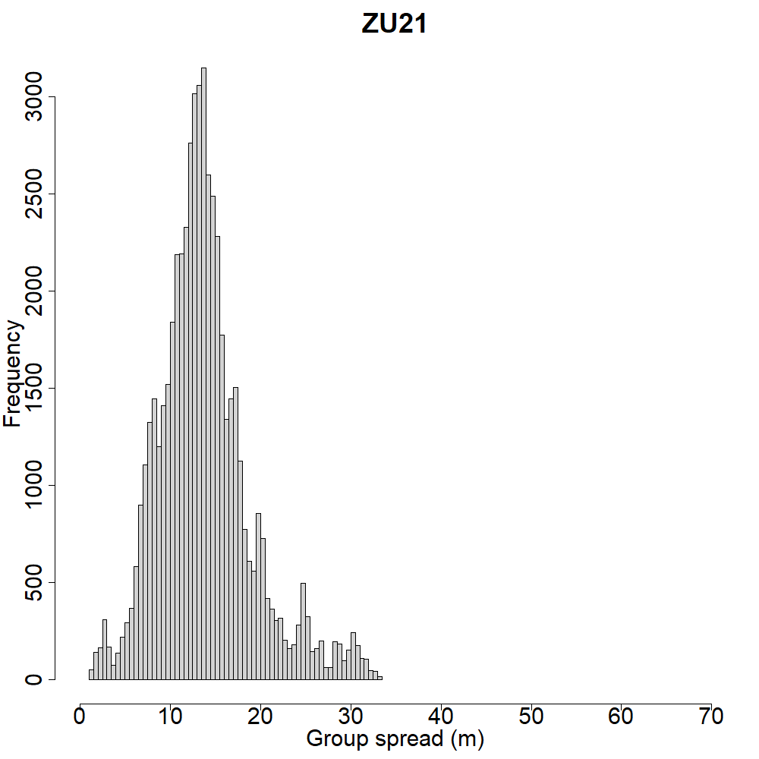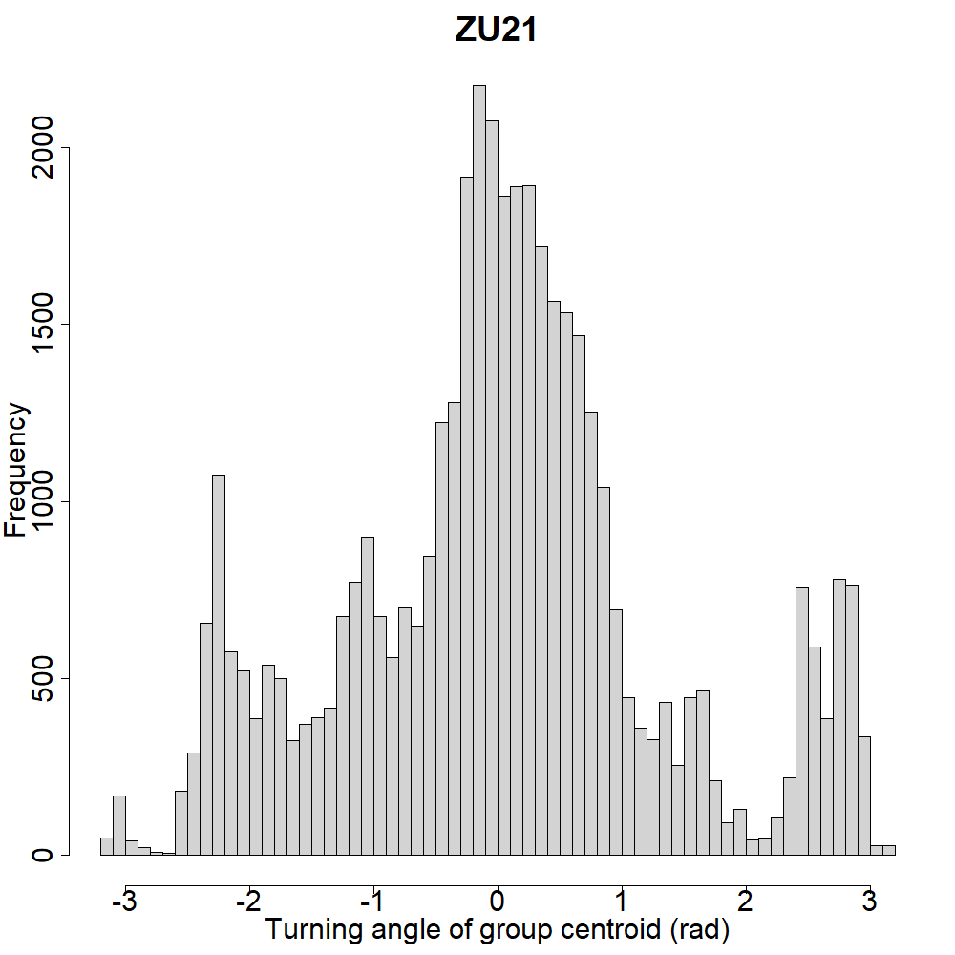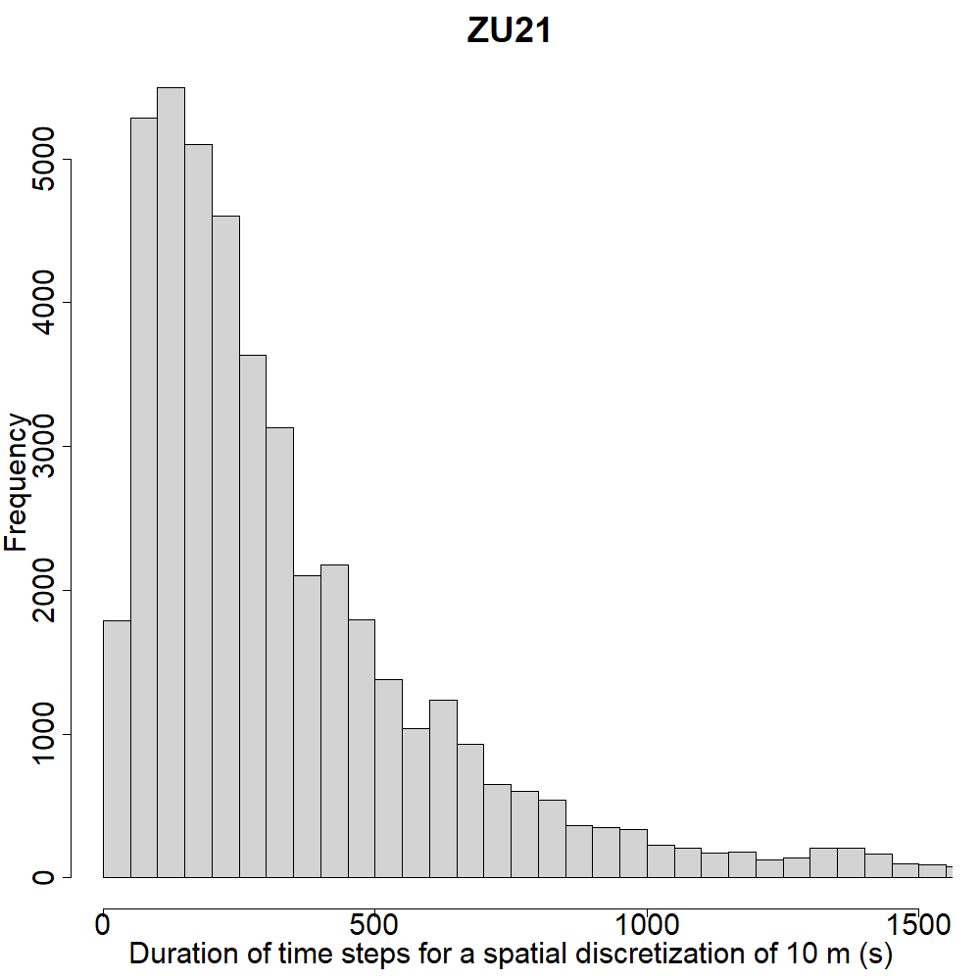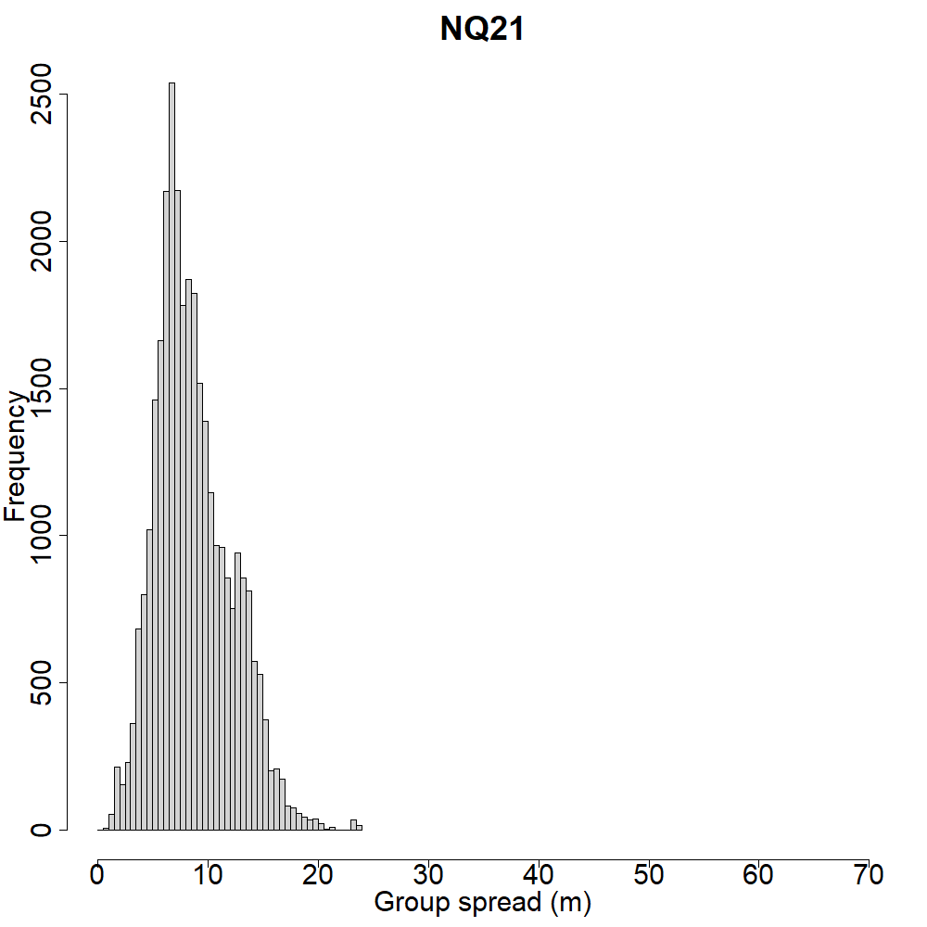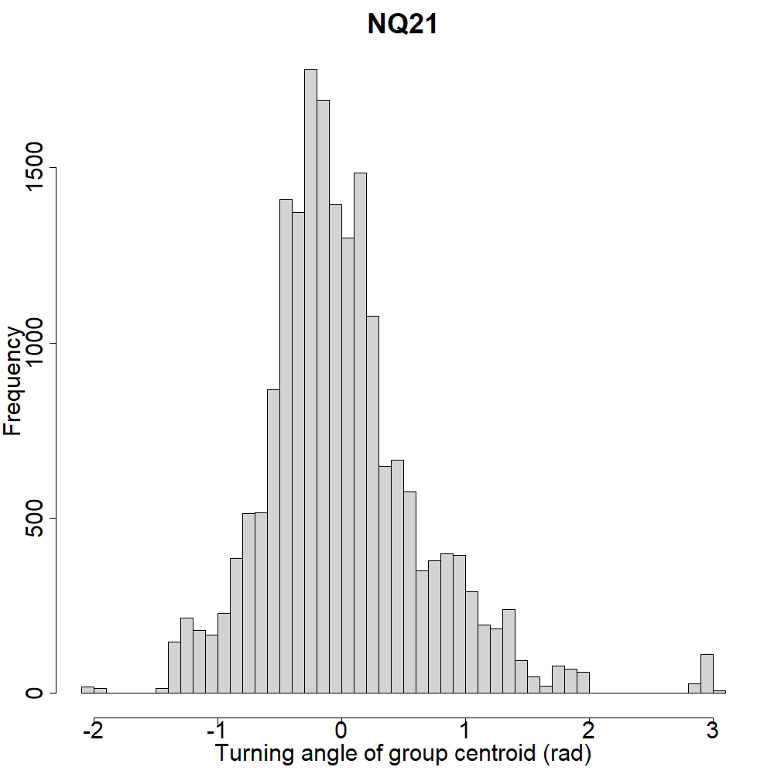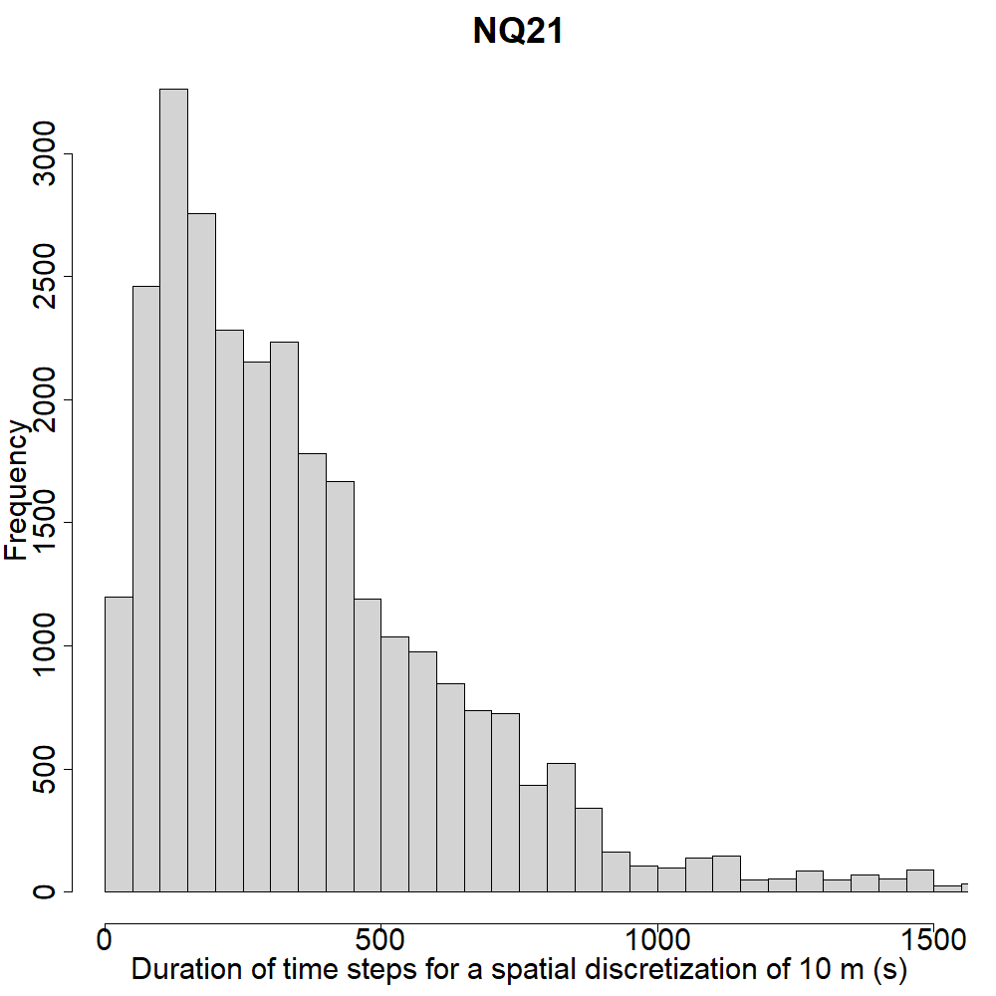

**5 - Robustness check: varying spatial discretization step**

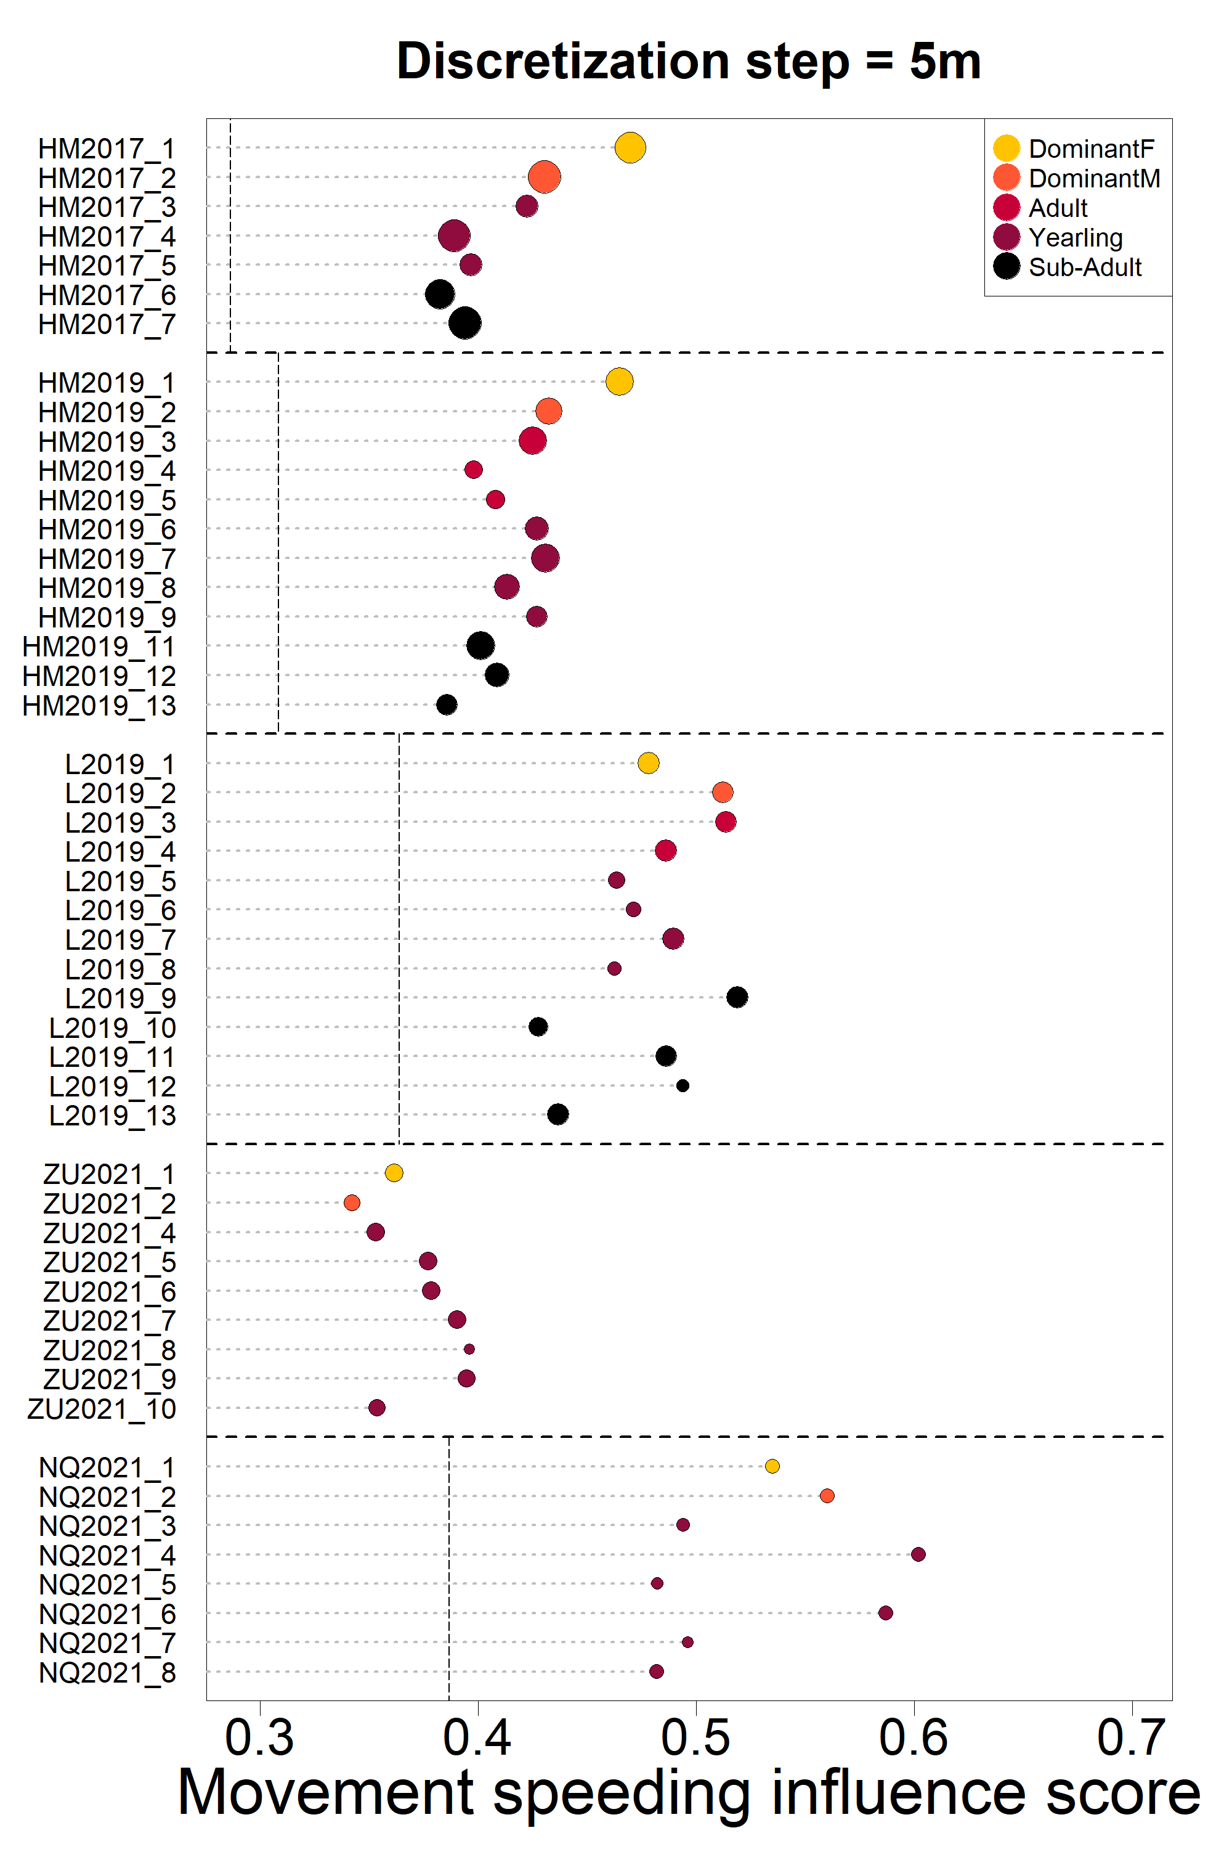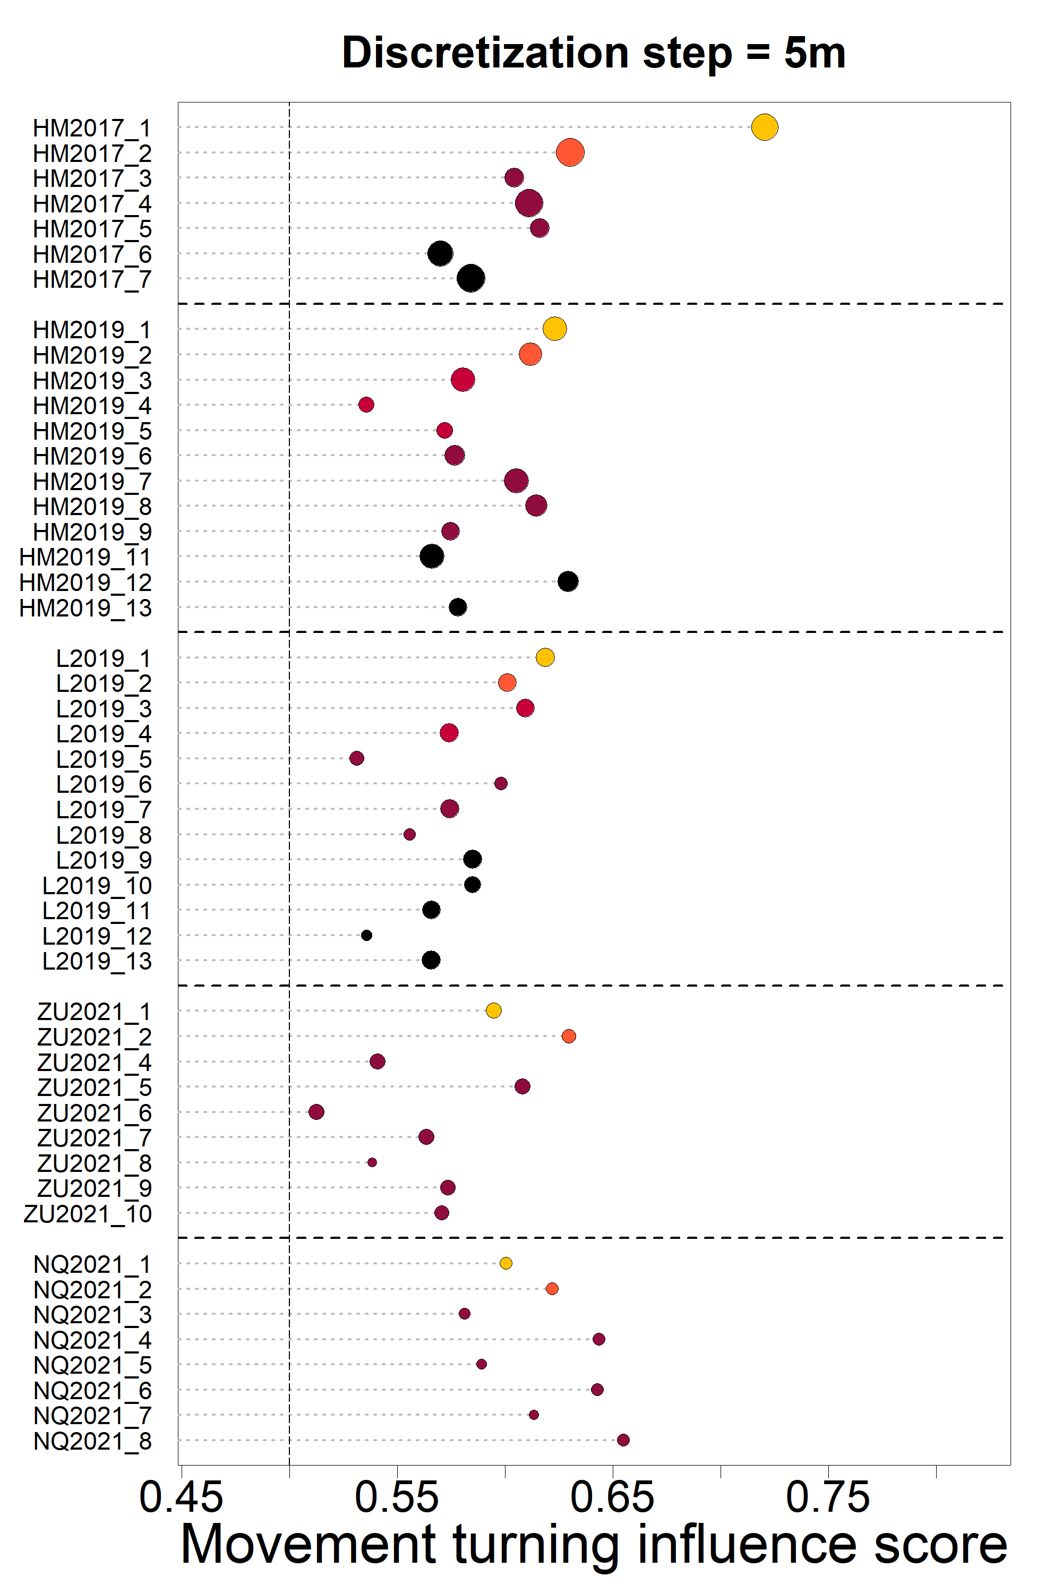Figures below show the individual turning influence score, speeding influence scores, and proportion of time spent in the front of the group, calculated with spatial discretization steps of 5, 15 and 20 meters, instead of 10 meters as presented in the main text. Plot layout is similar to that of figures 3 and 4 in the main text.

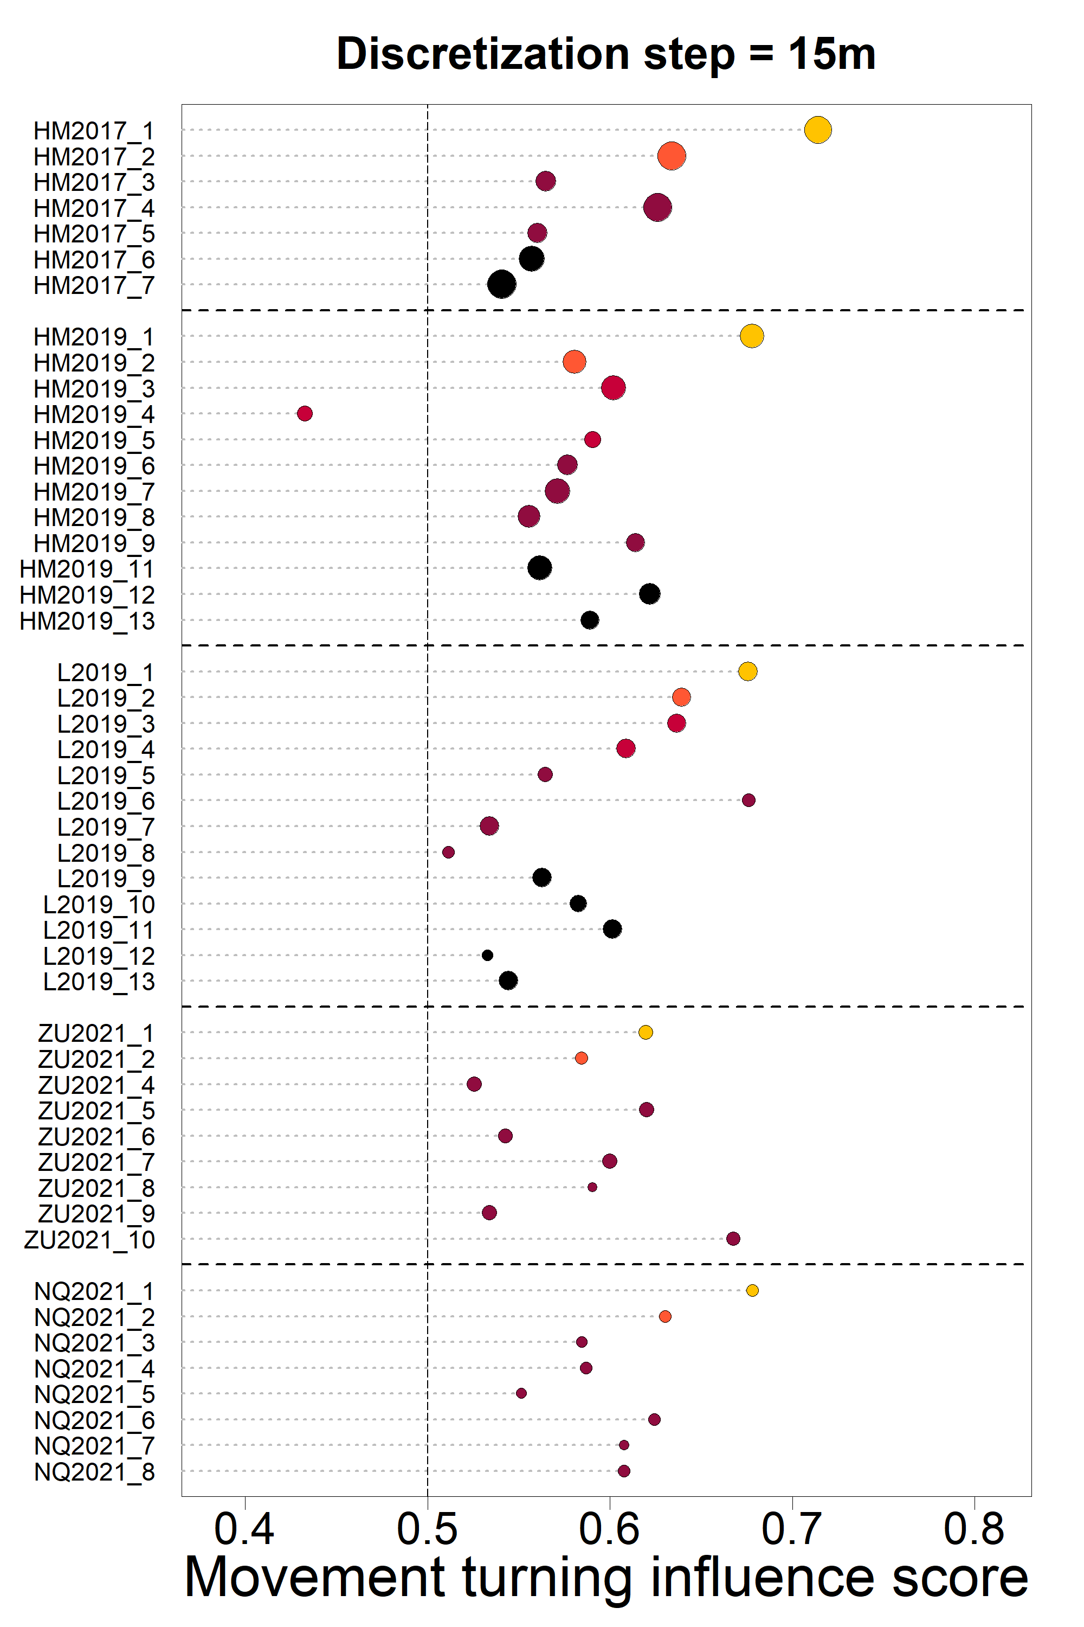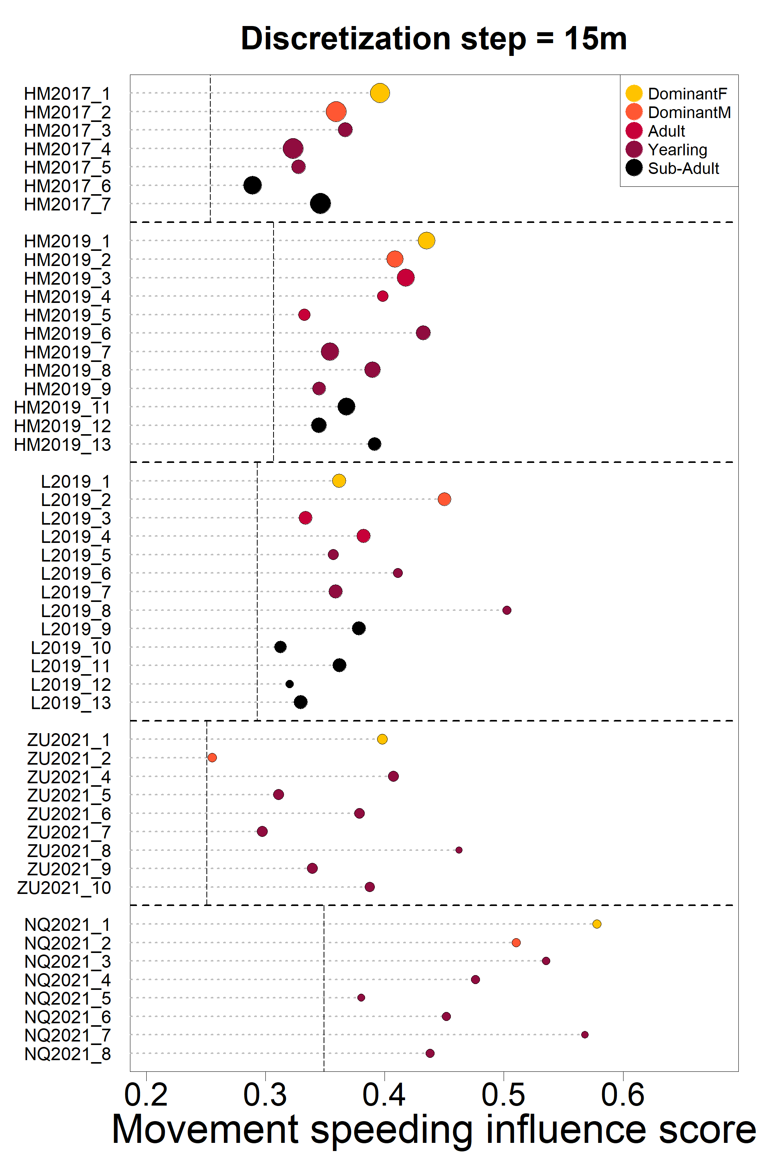

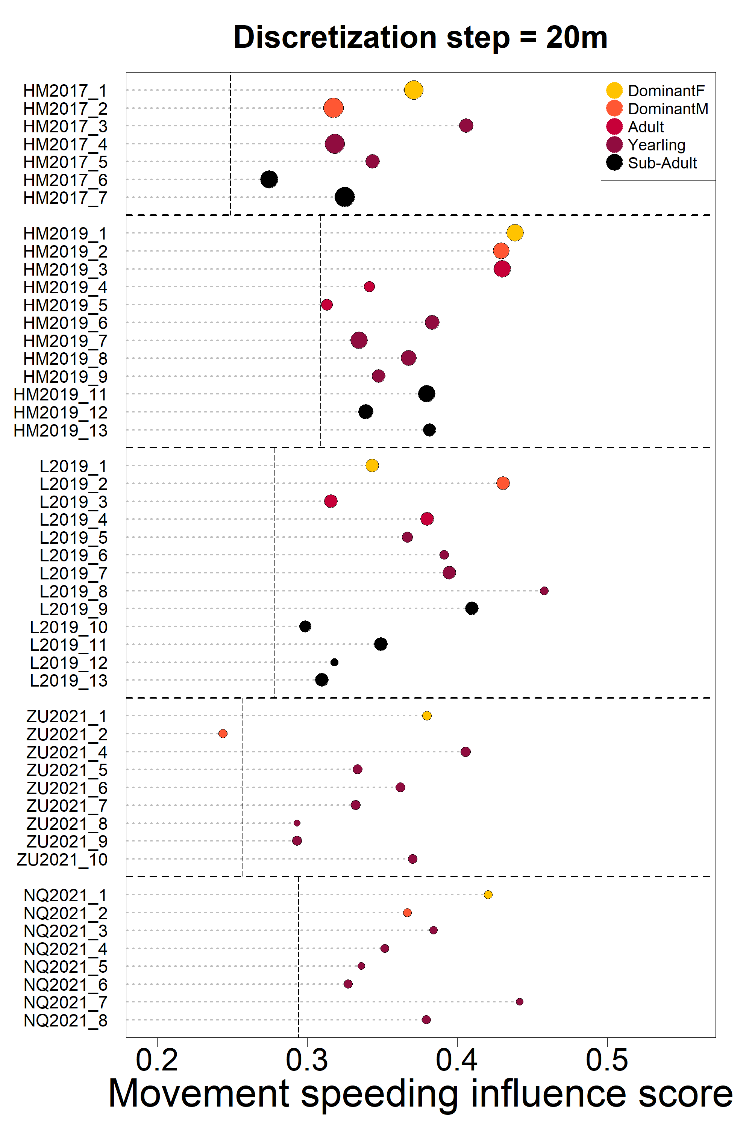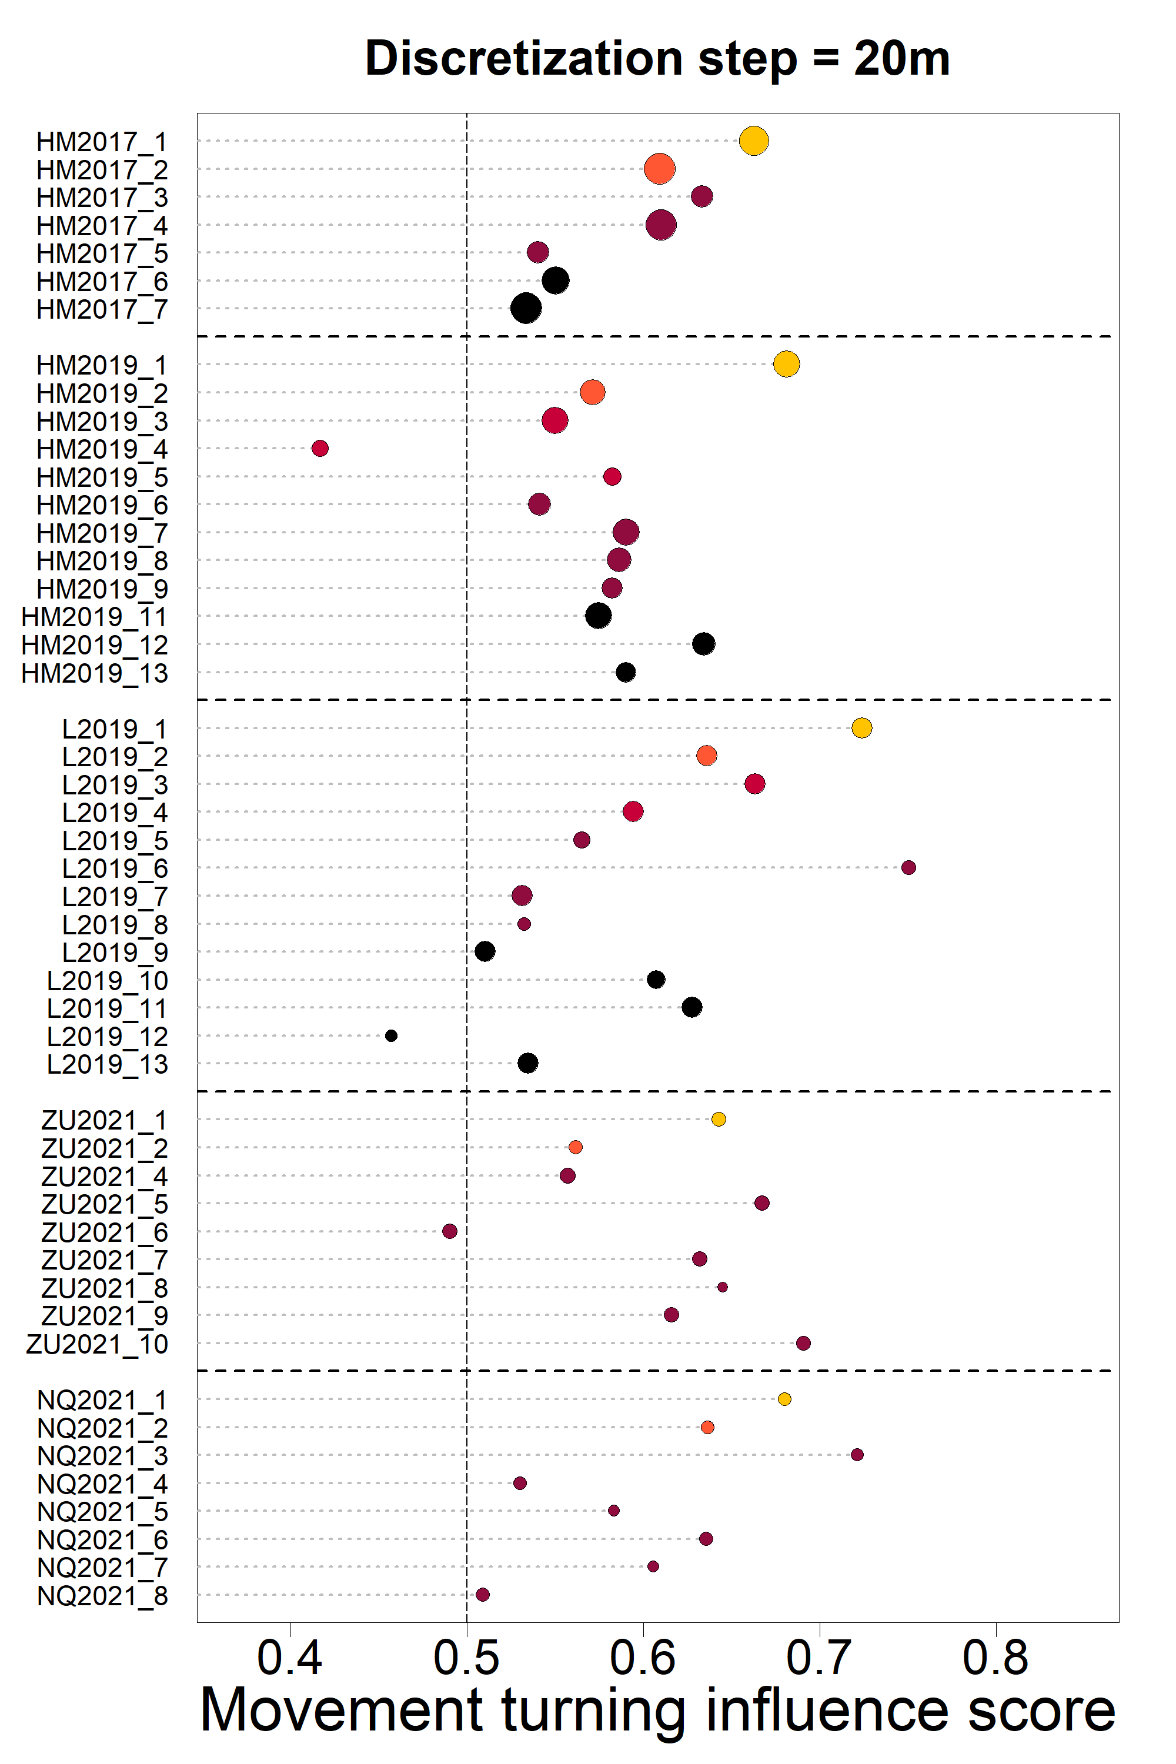

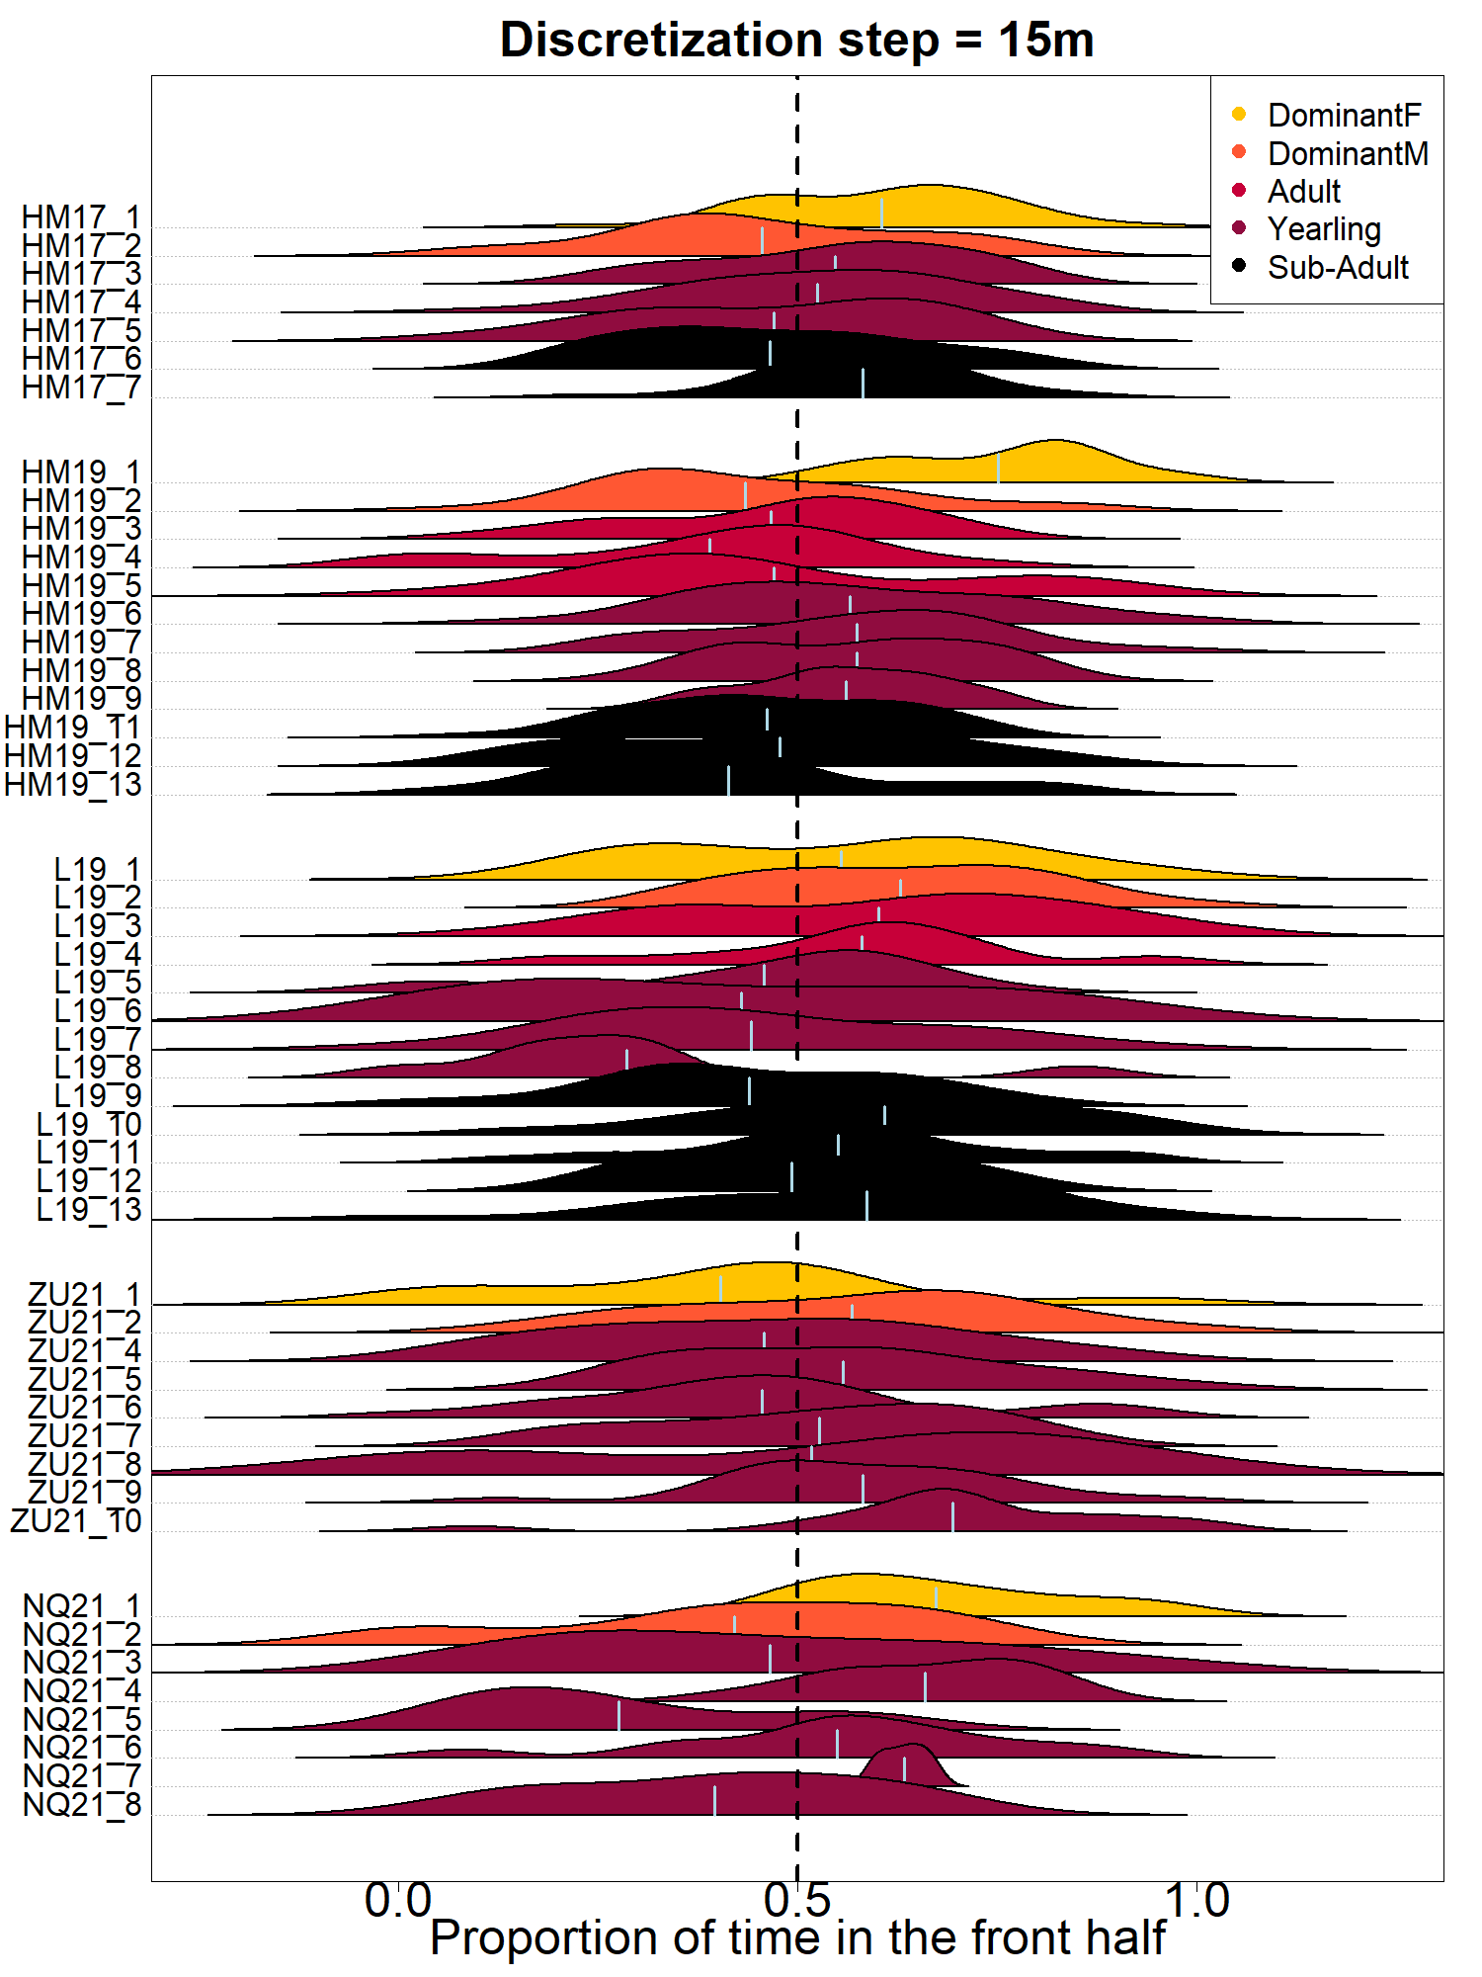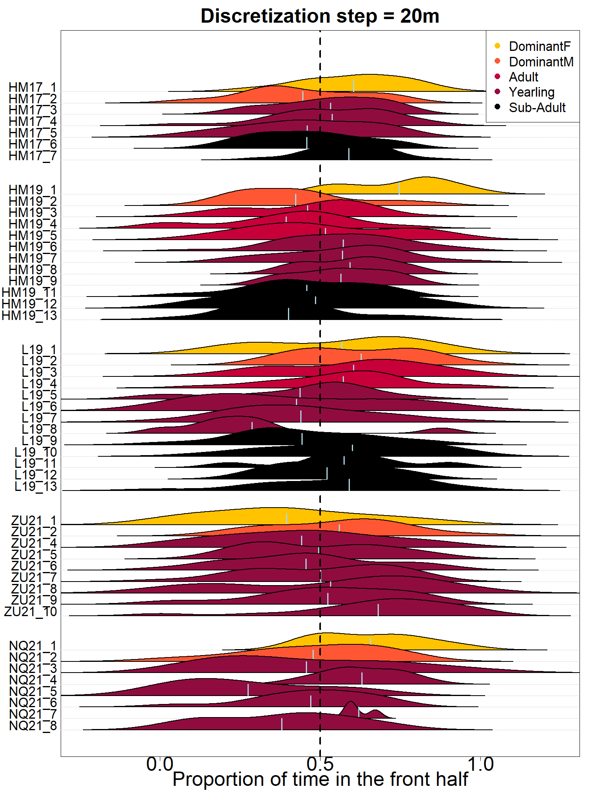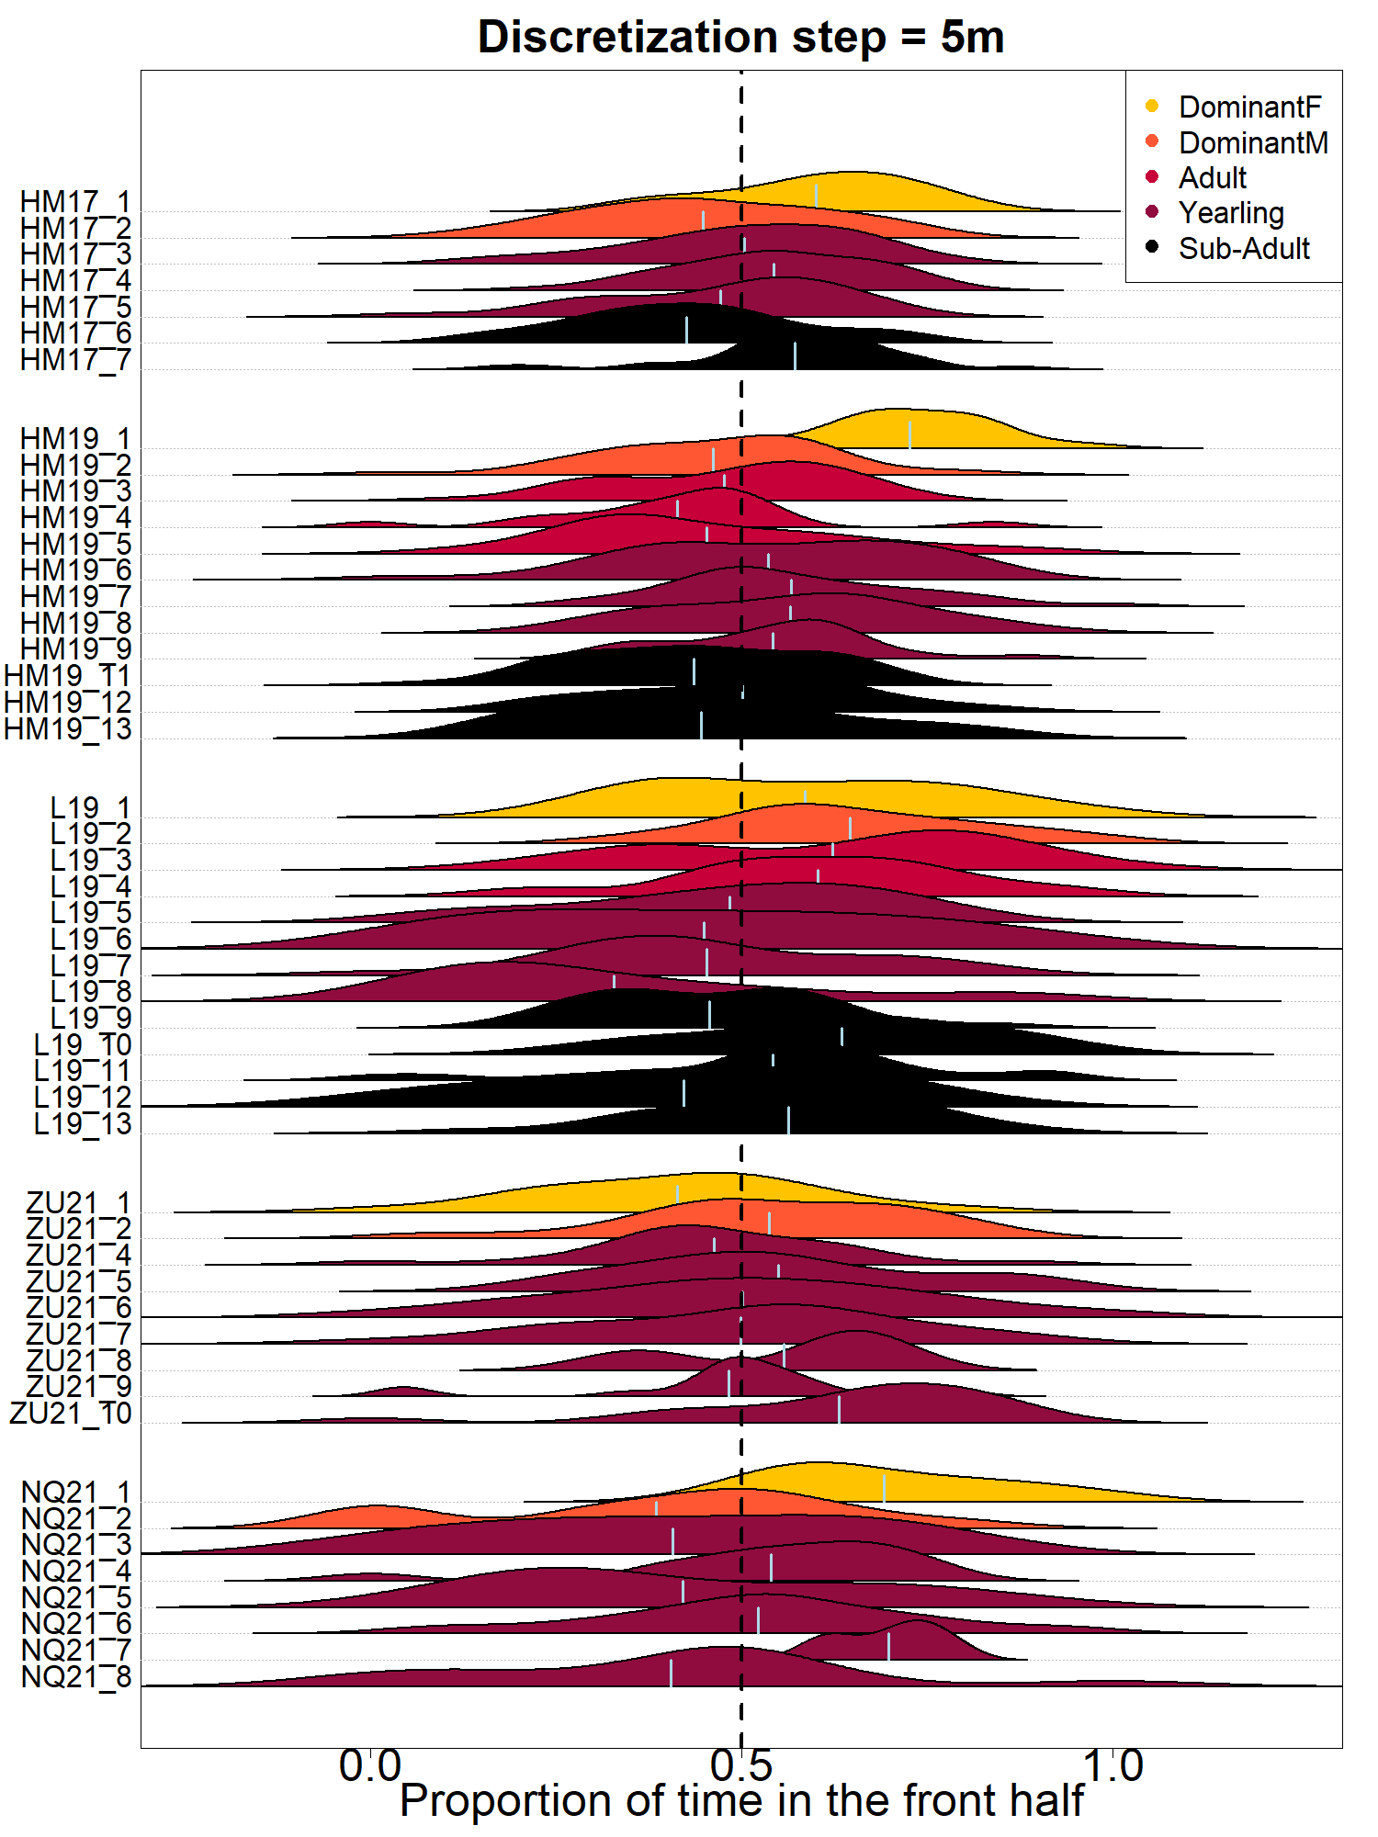

**6 - Results of post-hoc Tukey tests**

Turning influence scores:

Table S4. Results of post-hoc Tukey Constrasts comparing turning influence scores between the five social statuses. Each line tests the null hypothesis of no difference in the influence scores of the two statuses in the “comparison” column.

|  |  |  |  |
| --- | --- | --- | --- |
| **Comparison** | **Estimate** | **Std. Error** | **p-value** |
| DominantM - DominantF | -0.045 | 0.023 | 0.305 |
| Adult - DominantF | -0.094 | 0.024 | 0.001 |
| Yearling - DominantF | -0.089 | 0.018 | <0.001 |
| Sub-Adult - DominantF | -0.086 | 0.021 | <0.001 |
| Adult - DominantM | -0.049 | 0.024 | 0.250 |
| Yearling - DominantM | -0.044 | 0.018 | 0.108 |
| Sub-Adult - DominantM | -0.041 | 0.021 | 0.275 |
| Yearling - Adult | 0.005 | 0.019 | 0.999 |
| Sub-adult-Adult | -0.008 | 0.021 | 0.995 |
| Sub-Adult - Yearling | -0.003 | 0.015 | 0.999 |

Speeding influence scores:

Table S5. Results of post-hoc Tukey Contrasts comparing speeding influence scores between the five social statuses. Each line tests the null hypothesis of no difference in the influence scores of the two statuses in the “comparison” column.

|  |  |  |  |
| --- | --- | --- | --- |
| **Comparison** | **Estimate** | **Std. Error** | **p-value** |
| DominantM - DominantF | -0.013 | 0.020 | 0.967 |
| Adult - DominantF | -0.059 | 0.021 | 0.043 |
| Yearling - DominantF | -0.061 | 0.016 | 0.001 |
| Sub-Adult - DominantF | -0.078 | 0.018 | <0.001 |
| Adult - DominantM | -0.046 | 0.021 | 0.189 |
| Yearling - DominantM | -0.048 | 0.016 | 0.022 |
| Sub-Adult - DominantM | -0.065 | 0.018 | 0.004 |
| Yearling - Adult | 0.002 | 0.017 | 0.999 |
| Sub-adult-Adult | -0.018 | 0.018 | 0.838 |
| Sub-Adult - Yearling | -0.017 | 0.014 | 0.718 |

**7 – Individual fits for the four types of influence**

The figures below show the outcome of the model fit for each individual and each four type of influence. Each blue frame represents one individual and within each frame, the top-left plot shows the fit for the position turning influence, the top-right plot shows the fit for the movement turning influence, the bottom-left plot shows the fit for the position speeding influence, the bottom-right plot shows the fit for the movement speeding influence. In each plot, the black curve represents the binned data, with dot size indicating number of time steps used as shown in the bottom-right legend, the red curve shows the fitted line from our model, blue dotted lines show how the influence score is found. Top-left legend indicates the fitted parameter of the model, it’s log-likelihood, and the individual influence score. X-axis limits extend to the 0.01-0.99% quantiles of each variable to show them on comparable scales.

